Determinant of Employee Engagement and Its Implications on Employee Performance

Meswantri Meswantri¹, Awaludin Ilyas²
¹Univesritas Nasional Jakarta Indonesia. meswantri@solusisafety.com
²Univesritas Tjut Ntak Dhien. Aceh. Indonesia. awaludin.ilyas@gmail.com

Correspondet Author : correspondent.author@gmail.com

ABSTRACT
This study aims to analyze and prove partially or simultaneously the influence of transformational leadership, employee placement, competence and employee engagement on employee performance in construction and building companies in DKI Jakarta. The research method used in this research is descriptive quantitative method of causal approach from sample size of 237 respondents, data analysis method used is SEM (Structural Equation Modeling) through Lisrel Program.
Based on the results of the research, found that transformational leadership, employee placement and competence either partially or simultaneously have positive and significant effect on employee engagement with coefficient of determination (R2) of 51%. Similarly, transformational leadership, employee placement, competence and employee engagement either partially or simultaneously have a positive and significant effect on employee performance with the value of determination coefficient (R2) of 85%. To improve the performance of employees required the implementation of good transformational leadership, employee placement tailored to the potential and talents for employees, the competencies need to be improved and employee engagement should be improved.

Keywords: Transformational Leadership, Employee Placement, Competency, Employee Engagement, Employee Performance

JEL Classification : J0
- INTRODUCTION

The enactment of the era of Asean Economic Community (MEA) starting in 2016 has an impact on the level of increasingly fierce business competition in Indonesia. This is due to the entry to companies from countries incorporated into the MEA. This emerging competition makes companies able to grow or otherwise to decline to depend on the preparedness and strategy in the face of the competition.
Companies in the field of construction are also inseparable from the competition as expressed by the media which states that entering the Era of the ASEAN Economic Community, the entry to foreign construction services business (BUJKA) increasingly unstoppable.
Construction and building companies are classified into five types: Architecture, Civil, Mechanical, Electrical and Environmental (Central Bureau of Statistics 2016).
The number of construction and building companies in Jakarta Capital City by medium scale scale is 61.10% with the number of 5,870 businesses. While at least there is a Large-Scale Company / business there are 688 companies / business, can be presented in the following figure.
Based on data obtained from several constructions and building companies in DKI Jakarta about employee engagement and employee performance, it is found that there are still many employees that do not have employee engagement and high employee performance towards the company.
The decreasing level of employee engagement to the company can be seen from the level of employee discipline which is one of the characteristics of vigor. Discipline level can be seen in the form of employee attendance.
Settling through human resources is necessary in restoring the company's performance. Human resources are complex, unlike other production factors, human resources require good management, fostered and developed according to their talents and potentials. Management, development and human resource development of the company is expected to make qualified human resources and they have an attachment (employee engagement) to the company so they can work with high spirits so that employee performance increases and corporate goals are achieved`.
This is in accordance with research conducted by Anitha (2013), Allameh et al, (2014), Dajani (2015) stating that employee engagement has a significant effect on employee performance.
Many factors can affect employee performance such as: leadership style, organizational culture, employee placement, discipline training, employee engagement, employee welfare, emotional intelligence, job satisfaction, competence, work environment, organization citizenship behavior and so on. Factors that may affect the quality of this human resource should receive attention to the management company.

- LITERATURE REVIEW
  - Transformational Leadership
Robbins and Coulter (2012: 488) states that, Leadership is what leaders do. It's a process of leading a group and influencing that groups to achieve its goals. The leadership that creates positive and valuable change in followers is Transformational Leadership. Such leaders focus on "transforming" others to help each other, maintain one another, encourage and harmonize, and pay attention to the organization as a whole (Paracha et al, 2012).
As a complete approach, transformational leadership can be used to describe leadership in a wide range of highly specific efforts to influence followers on a one-on-one level, to a vast effort to influence an entire organization and even an entire culture. Although transformational leaders play an important role in causing change, followers and leaders are bound together in the transformation process. (Northouse, 2013: 175)
The transformational leadership theory provides evidence that when a leader uses a transformational leadership style, this theory generates the emotional attachment to followers or employees to the leader. The quality of the transformational leader can be judged by the impact that the leader has on followers. Employees develop trust and respect for transformational leaders and they are willing to exhibit extraordinary behavior to meet the expectations of their leaders (Barbuto, 1997 in Asrar-ul-Haq and Kuchinke, 2015).
The transformational leadership variable is measured from the following dimensions and indicators:
1. The ideal influence dimension with indicators of belief, sense of belonging and trust.
2. Dimension of inspirational motivation with indicators of communication, enthusiasm, and optimism.
3. The dimension of intellectual stimulation with indicators of creativity, rationality, and problem solving.
4. Dimensions of individual considerations with indicators of attention, mentoring, and development.

  - Employee Placement
Placement is a procurement of human resources, as stated by Hasibuan (2012: 22) that: Procurement is a process of withdrawal, selection, placement, orientation, and induction to get the appropriate employees with the needs. After the employee is eligible to pass the selection / acceptance, then the employee will be placed in the position or job position in accordance with the qualifications they have (Wahyudi, 2006: 95). Placement is a process of activities within a company to determine the location and position of an employee in the work.
According to Rivai (2013: 198) employee placement means allocating employees to a specific work position, this is especially true of new employees. To an existing employee that has held a position or occupation including the purpose of an employee placement function in the sense of maintaining his position or transferring to another position. According Siagian (2012: 168) placement not only applies to new employees, but also applies to old employees that experience the transfer of duties and mutations.

  - Competency
According to Rivai (2013: 198) employee placement means allocating employees to a specific work position, this is especially true of new employees. To an existing employee that has held a position or occupation including the purpose of an employee placement function in the sense of maintaining his position or transferring to another position. According to Siagian (2012: 168) the placement applies not only to new employees, but also to old employees that are overtaken by duties and mutations. Competence according to McClelland can be analogous to "icebergs" where competency and knowledge form the peak above water. The underside of the water is invisible to the naked eye, but becomes the foundation and has an influence on the shape of the part above the water (Rivai, 2013: 299)
According to McClelland (Rivai, 2013: 299) competence is a fundamental characteristic of a person that directly influences or can predict, excellent performance.
Boyatzis (2008) competence is defined as a fundamental characteristic of a person that can be a motive, trait, skill, aspect of self-image, social role, or knowledge he uses. These characteristics are revealed in observable and identifiable behavioral patterns, related to work performance and typically include knowledge, skills and abilities. In other definitions, competence is determined as the average able to perform work roles in established standards with reference to the actual work environment (Zaim et al, 2013).
Competence is a skill that is based on skills and knowledge supported by work attitude and its application in performing tasks and work at work which refer to the specified work requirements (Sutrisno, 2015: 203).
According to Government Regulation No. 101 Year 2000 article 3 mentions, competence is the ability and characteristics possessed by a civil servant in the form of knowledge, attitude behavior required in the task and position. While understanding the competence according to According to Boulter et al. (2003), competence is 'the basic characteristic of a person who allows employees to perform superior performance in their work'. Based on the above description of the meaning of competence contains a deep personality section and attached to a person with behavior that can be predicted on various circumstances and job tasks. The prediction of who performs well and less well can be measured from the criteria or standards used.
In line with the above understanding is Spencer and Spencer in Sutrisno (2015: 203) states that competence is the underlying characteristic of a person and is associated with the effectiveness of individual performance in his work. The definition contains the meaning of competence is a deep and attached personality to a person as well as behavior that can be predicted on various circumstances and job tasks.
Pate et.al (2003), distinguishes individual competence from the epistemological point of view as rationalist and objectivist. From a rationalist perspective, competence is a set of particular attributes used in doing the work. In the rationalist perspective there is a difference between work and worker. Thus, the job-oriented competency side is associated with the characteristics of outstanding employees such as the nature traits and social skills that can be learned through education, experience or vocational training. Therefore, this approach focuses on the interaction between individuals and occupations, thus, taking into account what individuals bring to the job and the characteristics of the work itself (Zaim et al, 2013).
Therefore, competence is a fundamental characteristic of each individual associated with the reference criteria of superior or effective performance in a job or situation. Spencer and Spencer (1993) in Wibowo (2016: 273) state that competence is the basis of people's characteristics and indicates how to behave or think, equate situations, and support for long periods of time.

  - Employee Engagement
Employee engagement is an emotional attachment to work and organization, motivated and able to provide their best ability to help succeed from a set of tangible benefits to organizations and individuals (McLeod, 2009: 4). David Guest believes it is helpful to see employee engagement as a way of working designed to ensure that employees are committed to the goals and values of their organization, motivated to contribute to the success of the organization, and at the same time in order to enhance the sense of well-being.
The engaged organizations have authentic power and value, with clear evidence of trust and fairness based on mutual respect, both of which have promises and commitments between employers and understood and fulfilled employee (McLeod, 2009: 5).
Engagement is defined as a positive, meaningful, and motivational attitude, characterized by vigor, dedication, and absorption. Vigor is characterized by high energy levels, resilience, a desire to strive, and not give up in the face of challenges. Dedication is characterized by feeling worth, enthusiastic, inspiring, valuable and challenging. Absorption is characterized by full concentration of a task, (Schaufeli & Bakker, 2010).
Kahn (2010) defines an Employee Engagement as a personal Engagement that utilizes itself as an organization member to perform their job roles; in that engagement the employed person expresses himself physically, cognitively and emotionally during his performance. This means how someone will interact with work and also with other employees and colleagues having a close relationship of work (Ferrer, 2005). Employees with high levels of Engagement, disclosing this feature and in performing the task have a lot of mental and physical involvement and have high respect in their work and duties and create an emotional connection with their work. Involvement in the applied sense as a psychological characteristic such as: Cognition and emotion and behavior, including motivational cases applied Concepts such as job satisfaction and organizational commitment apart from them (Shuck, Ghosh, Zigarmi & Nimon, 2013).
Understanding Employee Engagement by Robbins and Judge (2008) is an individual employee engagement, satisfaction, and enthusiasm to do his job. Robinson et al (2004) defines Employee Engagement as a positive attitude that employee attitudes toward the company where he works and the values that exist within the company.
The things that can be the driving force Employee engagement are the organizational culture, vision and values adopted. The organization culture is an organization that has openness, mutual support and good communication between colleagues (McBain, 2007: 25).
According to Schaufeli & Bakker (2003: 25) employee engagement consists of three elements namely vigor, dedication and absorption.
1) Vigor is the employee's attachment shown through its physical and mental strength while doing the job. Vigor is characterized by high levels of strength and mental resiliency in work, optimal energy, courage to do the best effort, desire, willingness and willingness to strive earnestly in the work so as to give maximum results in any given job, persistent, not easily give up, the spirit and continue to survive in the face of adversity.
2) Dedication is an emotional attachment to employees to their work. Dedication describes the enthusiastic feelings of employees in the work, proud of the work done and the company where they work, remain inspired and remain diligent to the end of the company without feeling threatened by the challenges encountered. People who have high dedication score strongly to identify their work because it makes it a valuable, inspiring and challenging experience. They usually feel enthusiastic and proud of their work and organization. While low scores of dedications mean not identifying themselves with work because they have no meaningful, inspiring or challenging experience, moreover they feel unenthusiastic and proud of their work and organization.
3) Absorption is an employee attachment that is described by employee behavior that gives full attention to its work. Absorption describes the state of an employee that is happy to be totally immersed, concentrated, and serious in doing his job. While doing their work, they tend to make the time pass so quickly that they find it difficult to let go or separate themselves from work.

  - Performances
According to Colquitt et al, (2011: 35) states that performance is the value of a series of worker behavior that contributes, both positively and negatively, there is a settlement of organizational goals. Another opinion states that performance is the result of work related to organizational goals such as quality, efficiency and other performance of effectiveness (Gibson, et al, 2012: 374). Rogelberg (2007), has determined the performance of activities that are usually part of the work and individual activities and must do so.
According Sinambela (2016: 480) employee performance is the ability of employees in doing certain skills. Employee performance is very necessary, because with this performance will be known how far their ability in carrying out tasks assigned to him. Mangkunegara (2011: 93) performance is the result of work in quality and quantity achieved by an employee in performing their duties in accordance with the responsibilities given to him. Wibowo (2016: 7) performance is about doing the job and the results achieved from the job. Performance is about what to do and how to do it.
Measurements made only have an interest to measure what is important and relevant. It is therefore necessary to be clear about what is said to be important and relevant before determining what size should be used. The things that need to be measured depend on what is considered important by stakeholders and customers. Measures govern the blessing between customer-oriented strategies and goals with action (Wibowo, 2016: 155).
Performance appraisal by Mathis & Jackson (2003: 342) is: "Performance appraisal is the process of evaluating how well employees perform their jobs when compared to a set of standards and then communicating that information to those employees". Performance appraisal by Hasibuan (2001: 86) is "the activities of managers to evaluate employee performance behaviors and establish the next policy”.
Gomes (2013: 142), revealed that performance appraisals include:
1. Quantity of work is the amount of work done within a predetermined time period.
2. Quality of work is the quality of work achieved based on the requirements and preparedness.
3. Job knowledge is the breadth of knowledge about work and skills
4. Creativity is the authenticity of the ideas raised and the action of the skill
5. Cooperation is the willingness to cooperate with others.
6. Dependability is awareness and can be entrusted in terms of attendance and work completion.
7. Dependability is awareness and can be entrusted in terms of attendance and work completion.
8. Personal quality is related to personality, leadership, hospitality, and personal integrity.

- RESEACRH METHOD
The method used in this research is quantitative descriptive research method of causal approach. This study is intended to build a real picture of a phenomenon that is in the context of his research. With this descriptive research will be collected a variety of informations in order to test the hypothesis or answer questions that concern the problem of research. Causal approaches is a research to determine the effect of one or more independent variables (independent) on the dependent variable.
The population of this study is taken from all employees that work in construction and building companies in DKI Jakarta. Construction and building companies have large business qualifications (B1 and B2) and are engaged in Mechanical and Electrical. The total number of permanent employees totaled 2,437 people. While the number of samples taken using sampling technique purposive sampling, the sampling technique based on certain considerations.
The basic considerations used in determining the number of samples are as follows:
1. The company's permanent employees
2. Employees who have manager-level positions
Based on these considerations, the number of research samples is 237 people.

- RESEARCH RESULT AND DISCUSSIONS

  - Validity and Reliability Test
The validity test is used to identify dimensions or factors that explain the correlation in a variable. Validity tests using Kaiser-Meyer-Olkin (KMO) with good KMO value ≥ 0,50. The higher the KMO values indicate that the factor analysis is appropriate. As for to measure reliability with statistical value of Cronbach alpha (α). A construction or variable is deemed unfavorable if the value of Cronbach alpha (α) is less than 0.6 and is acceptable if it reaches a value of 0.7.

Table 1. Validity and Reliability Test Results
Variable Let | Indicator | KMO and Bartlett’s Test | Cronbach’s Alpha
Transformational leadership | KT1 – KT12 | 0,812 | 0,787
Employee Placement | PK1 – PK19 | 0,876 | 0,802
Competence | KS1 – KS15 | 0,915 | 0,885
Employee Engagement | EE1 – EE12 | 0,915 | 0,873
Employee performance | KK1 – KK14 | 0,892 | 0,851
Source: SPSS Test Results, 2017
Based on table 3 shows that validity testing for KMO and Bartlett's Test has values above 0.5 and reliability testing with Cronbach's Alpha has a value above 0.7 so it can be concluded that the validity and reliability test for the data onto the respondents has proved valid and reliable.

4.2. SEM analysis
4.2.1. Validity and Reliability Testing on SEM
Validity tests is done using second order confirmatory factor analysis (2ndCFA), and each statement item with sample number 237 must have loading factor  0.35....

4.2.2. Model Feasibility Test
Model feasibility tests is performed to achieve a good model and meet the requirements of GOF in Structural Equation Modeling, the complete SEM model can be seen in the following figure.
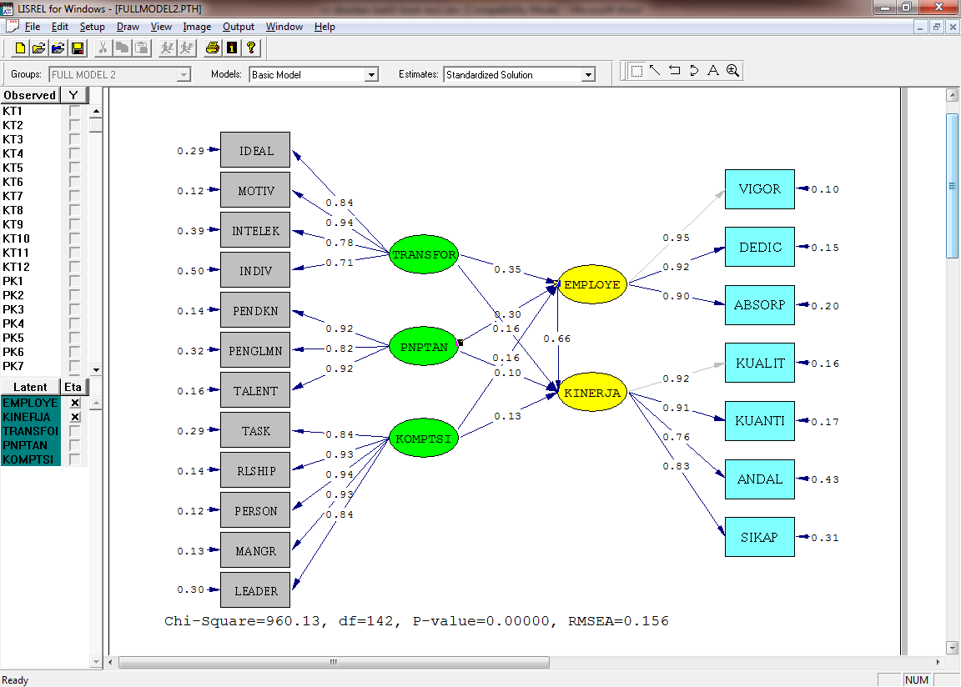
Source: Lisrel Data Processing Results 8.80

Figure 2. Full Model Path Diagram (Standardized Solution)

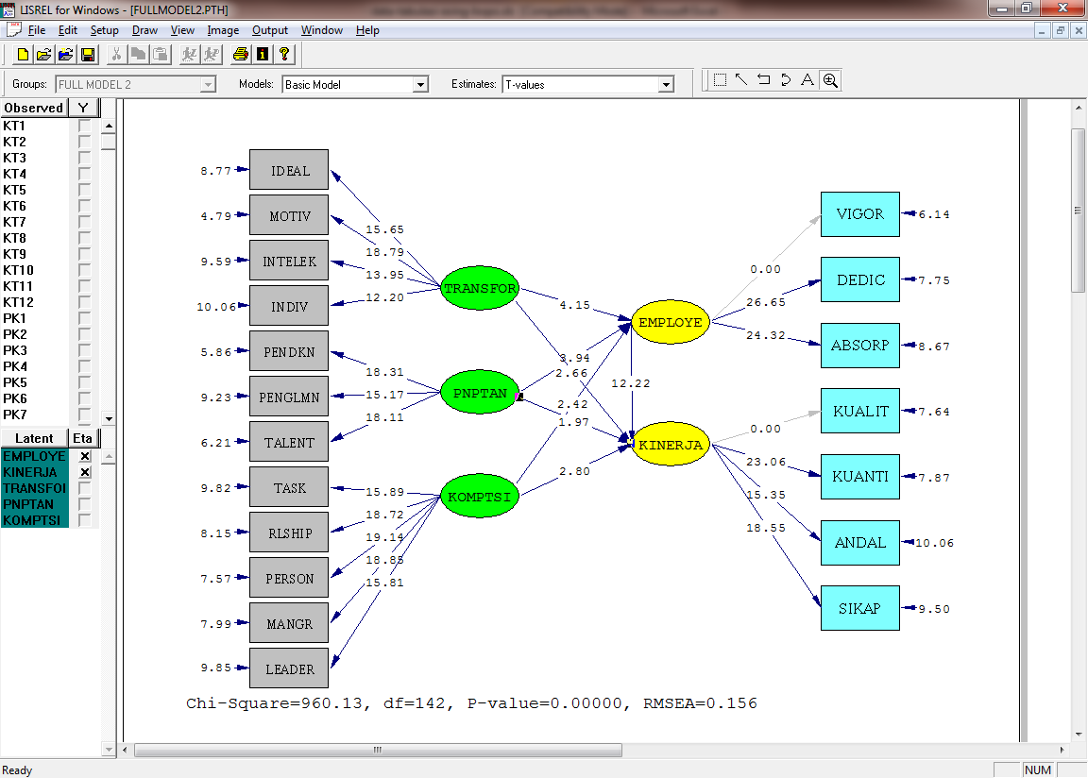

Source: Lisrel Data Processing Results 8.80

Figure 3. Full Model Model Chart (T-Values)

In the t-values estimation results from Figures 2 and 3, there are variables that do not have a path that is the relationship of Employee variable to Vigor dimension and the relation of performance variable to Quality dimension. This is because the variable has been defined to be a reference variance which means that the manifest variable is significantly related to the latent variable (Wijanto, 2015).
Based on the model of full model line diagram above, then to be able to analyze the hypothesis of this study needs to be tested for overall fit model (Goodness of Fit Index Full Model Structural). The evaluation of GOF from the research model can be seen in the following table.

Table 2. Goodness of Fit Index Full Model
No | GOF Size | Match Rate | Result | Conclusion
1 | Chi-Square (χ²)  P > 0,05 | Expected small  P ≥ 0,05 | 960,13  P = 0,05 | Marginal
2 | RMSEA | ≤ 0,08 | 0,16 | Marginal
3 | NFI | ≥ 0,90 | 0,90 | Good
4 | NNFI | ≥ 0,90 | 0,90 | Good
5 | PNFI | Expected High | 0,75 | Good
6 | CFI | ≥ 0,90 | 0,91 | Good
7 | IFI | ≥ 0,90 | 0,91 | Good
8 | RFI | ≥ 0,90 | 0,88 | Marginal
9 | GFI | ≥ 0,90 | 0,70 | Marginal
Source: Wijanto, 2015 and Lisrel Processing Results 8.80

If seen in table 4. all estimates of goodness fit values of structural models have good values although there are some marginal ones such as Chi-Square and GFI but overall the estimated structural model is acceptable, so it can be said the relationship of various constructs in this variable is a structural relationship. This may be justified in the opinion of Hair (2010) that the use of 4 - 5 goodness of fit criteria is considered sufficient to assess the feasibility of a model, provided that each criterion of goodness of fit is absolute fit indices, incremental fit indices, and parsimony fit indices represented.

4.3. Hypothesis testing
4.3.1 The Influence of Transformational Leadership to Employee Engagement
Obtain estimates of transformational leadership influence on employee engagement to 0.35 and t-value of 4.15. Where the value of t-value 4.15> 1.96 so that Ho is rejected and H1 accepted which mean there is influence of transformational leadership towards employee engagement. As for the determination coefficient is 0.51 which mean the amount of contribution to influence of transformational leadership of employee engagement is equal to 51%. According to the above calculation results can be concluded that hypothesis 1 proposed can be accepted.
    - The Influence of Employee Placement on Employee Engagement
Obtain estimation of transformational leadership influence over the competence of 0.30 and t-value of 3.94. Where the value of t-value 3.94> 1.96 so Ho is rejected and H2 accepted which means there is influence placement of employees to employee engagement. As for the determination coefficient is 0,51 which mean the amount of contribution influence of employee placement of employee engagement is equal to 51%. According to the above calculation results can be concluded that hypothesis 2 submitted can be accepted.

    - The Influence of Competence to Employee Engagement
Based on the result of calculation in the above table we get estimation of transformational leadership influence over the competence of 0.16 and t-value of 2.42. Where the value of t-value 2.42> 1.96 so that Ho is rejected and H3 accepted which mean there is influence of competence of employee engagement. As for the determination coefficient is 0,51 which means the amount of contribution influence of employee placement to employee engagement is equal to 51%. According to the above calculation results can be concluded that hypothesis 3 proposed can be accepted.

    - The Influence of Transformational Leadership, Employee Placement and Competence simultaneously to Employee Engagement
Based on the results of Lisrel 8.8 the following equations are obtained:
EMPLOYE=0.35*TRANSFOR+0.30*PNPTAN+0.16*KOMPTSI, Errorvar. = 0.49, R² = 0.51
(0.085) (0.076) (0.067) (0.055)
4.15 3.94 2.42 8.95
From result of equation of regressing obtained value of F_{count} equal to 8,95 whereas F_{table} values used  = 5% with degrees of freedom df = (k-1) and (nk) then with 3 free variable and sample 237 (F0,05; 2; 234) obtained Ftable value of 3.03, so Fcount (8.95)> Ftable (3.03). This means that there is an effect of transformational leadership, employee placement and competence simultaneously to employee engagement in construction and building companies. According to the above calculation results can be concluded that hypothesis 4 proposed can be accepted.
    - The Influence of Transformational Leadership on Employee Performance
the influence of transformational leadership on employee performance of 0.16 and t-value of 2.66. Where the value of t-value 2.66> 1.96 so Ho is rejected and H1 accepted which means there is influence of transformational leadership on employee performance. As for the determination coefficient is 0.85 which mean the amount of influence of transformational leadership on employee performance is 85%. According to the above calculation results can be concluded that hypothesis 5 proposed can be accepted.

    - The Influence of Employee Placement on Employee Performance
Based on the calculation in the table above obtained the estimated influence of employee placement of employee performance of 0.10 and t-value of 1.97. Where the value of t-value 1.97> 1.96 so Ho is rejected and H1 accepted which mean there is influence of employee placement of employee performance. As for the determination coefficient is 0.85 which means the amount of influence employee placement on employee performance is 85%. According to the above calculation results can be concluded that hypothesis 6 submitted can be accepted.

    - The Influence of Competence on Employee Performance
Based on the calculation in the table above obtained estimation of the influence of competence on employee performance of 0.13 and t-value of 2.80. Where the value of t-value 2.80> 1.96 so Ho is rejected and H7 accepted which means there is an influence of competence on employee performance. As for the determination coefficient is 0.85 which mean the amount of influence of competence on employee performance is 85%. In accordance with the above calculation results can be concluded that the proposed hypothesis 7 can be accepted.

    - The Influence of Employee Engagement on Employee Performance
Based on the calculation in the table above obtained estimation of employee engagement
effect on employee performance equal to 0,66 and t-value equal to 12,22. Where the value of t-value 12.22> 1.96 so Ho is rejected and H1 accepted which means there is influence employee engagement on employee performance. As for the determination coefficient is 0.85 which mean the amount of influence employee engagement on employee performance is 85%. According to the above calculation results can be concluded that the proposed hypothesis 8 is acceptable.

    - The Influence of Transformational Leadership, Employee Placement, Competence and Employee Engagement simultaneously on Employee Performance
Based on the results of Lisrel 8.8 the following equations are obtained:

From result of equation of regressing obtained value of Fvalue equal to 8,95 while Ftable values used  = 5% with degree of freedom df = (k-1) and (nk) hence with 4 independent variable and sample 237 (F0,05; 3; 233) obtained Ftable value of 2.64, so Fcount (8.95)> Ftable (2.64). This means that there is an effect of transformational leadership, employee placement, competence and employee engagement simultaneously on employee performance in construction and building companies by 85%. According to the above calculation results can be concluded that hypothesis 9 submitted can be accepted.

  - Direct and Indirect Influence
Analysis of influence is intended to see how strong the influence of a variable with other variables either directly, or indirectly. Interpretation of the results of this study will have an important meaning to determine a clear strategy in order to improve employee performance.
4.4.1. Direct and Indirect Influence Transformational Leadership on Employee Performance through Employee Engagement
The direct influence of transformational leadership on employee performance is 0.352 (0.12) whereas indirect influence over employee engagement is 0.35 x 0.66 = 0.23. This suggests that transformational leadership can improve employee performance when employees have employee engagement.
4.4.2. Direct and Indirect Effect of Employee Placement on Employee Performance through Employee Engagement
The direct effect of employee placement of employee performance is 0.302 (0.09) whereas indirect influence over employee engagement is 0.30 x 0.66 = 0.20. This shows that employee placement can improve employee performance if employee has employee engagement.
    - Direct and Indirect Effect of Competence on Employee Performance through Employee Engagement
The direct influence of competence on employee performance is 0.162 (0.03) while the indirect effect of employee engagement is 0.16 x 0.66 = 0.11. This shows that competence can improve employee performance if employees have employee engagement.
Based on the results of direct and indirect impact test in the above table it can be said that employee engagement acts as a full mediating where transformational leadership, employee placement and competence can improve employee performance if employees have employee engagement.

Based on the results of hypothesis testing and discussion on the theories in the previous chapters then carried out the discussion and interpretation as follows:
1. The Influence of Transformational Leadership to Employee Engagement
Based on the research results obtained value t-value 4.15> 1.96 so Ho is rejected and H1 accepted which means there is influence of transformational leadership towards employee engagement.
Based on the research results obtained value t-value 4.15> 1.96 so Ho is rejected and H1 accepted which means there is influence of transformational leadership towards employee engagement.
Well-implemented transformational leadership in a company can affect employees in terms of work motivation, job satisfaction, trust in leadership so that employees are more eager to achieve company goals and will affect employee engagement (employee engagement).
The results of this study support research conducted by Bezuidenhout & Schultz. (2013) which states that transformational leadership affects employee engagement.

2. The Influence of Employee Placement on Employee Engagement
Based on the research results obtained t-value value 3.94> 1.96 so Ho is rejected and H2 accepted which means there is influence placement of employees to employee engagement.
Employee placement is allocating employees to certain work positions, this is especially true of new employees. To an existing employee that has held a position or occupation including the objective of the employee placement function in the sense of maintaining his position or transferring to another position (Rivai, 2013: 198).
Previous employee placements are conducted by performing talent mapping to seek the interests, talents and potential of the employee. Talents mapping are done with a series of questions asked to employees then assessed strengths and weaknesses, with the knowledge of these strengths and weaknesses can be used as guidance in placing employees in the field of work that is appropriate.
If the employee's placement is in accordance with the talent, interest and potential will make employees more understanding of their work, the pleasure of their work, has a high spirit of work so that this can increase employee engagement to the company.
The results of this study support research conducted by Fernandes, Michele (2015), Memon et al, (2015) which states that employee placement affects employee engagement.

3. The Influence of Competence to Employee Engagement
Based on the research results obtained t-value 2.42> 1.96 so Ho is rejected and H3 accepted which means there is influence of competence to employee engagement.
Competence is an ability to perform or perform a job or task based on skills and knowledge and supported by the work attitude demanded by the work (Wibowo, 2016: 271).
High employee competence is expected to work with focus, have cooperation, can solve problems, work with high motivation, have leader spirit, so that this condition can create employee engagement to company and also can improve its performance.
The results of this study support research conducted by Marthandan (2017), Kolibačova (2014) which said that competence affects employee engagement.

4. The Influence of Transformational Leadership, Employee Placement and Competence simultaneously to Employee Engagement
Based on the result of regression equation obtained value Fvalue (8,95)> Ftable (3.03). This means that there is an effect of transformational leadership, employee placement and competence simultaneously to employee engagement in construction and building companies.
Well-implemented transformational leadership, employee placement in accordance with talents, interests and potential and high employee competence can create a reliable employee, working vigorously so that employee engagement to the company is increasing.

5. The Influence of Transformational Leadership on Employee Performance
Based on the research results obtained t-value 2.66> 1.96 so Ho is rejected and H5 accepted which means there is influence of transformational leadership on employee performance.
Well-implemented transformational leadership in a company can affect employees in terms of work motivation, job satisfaction, trust in leadership so that employees are more eager to support the achievement of corporate goals that will affect the performance of employees.
The results of this study support the research conducted by Paracha et al. (2012), Jyoti et al, (2015), Asrar-ul-Haq and Kuchinkeb (2016), Sougui et al, (2015), Babatunde and Emem (2015) states that transformational leadership affects employee performance.

6. The Influence of Employee Placement on Employee Performance
Based on the research results obtained t-value value 1.97> 1.96 so Ho is rejected and H6 accepted which means there is influence of employee placement on employee performance.
If the placement of employees is in accordance with the talent, interest and potential will make employees more understanding of their work, a sense of pleasure to work, has high morale in the work so that the work is charged can be completed in accordance with the target company that has been planned means employee performance can increase.
The results of this study support the research conducted by Chinomona et al, (2013), June et al, (2013), Yi-Chang Lin (2014) which states that employee placements affect employee performance.

7. The Influence of Competence on Employee Performance
Based on the research results obtained value t-value 2.80> 1.96 so Ho is rejected and H6 accepted which means there is influence competence on employee performance.
High employee competence is expected to work with focus, have cooperation, can solve problems, work with high motivation, have leader soul. High employee competencies can improve the completion of work targeted by the company.
The results of this study support research conducted by June et al, (2013), Kolibačova Gabriela. (2014), Wen and Guo (2016), Zaim et al, (2013) stating that competence affects employee performance.

8. The Influence of Employee Engagement on Employee Performance
Based on the research results obtained value t-value 12.22> 1.96 so Ho is rejected and H6 accepted which means there is an influence of competence on employee performance.
Employee engagement is an emotional attachment to work and organization, motivated and able to provide their best ability to help succeed from a series of tangible benefits to organizations and individuals (McLeod, 2009: 4).
Employee engagement to the company makes employees feel they belong to the company and will do the job as targeted by the company, give full support to company policy and discipline to the work.
The results of this study support research conducted by Allameh et al, (2014), Dajani (2015), Anitha (2013), Chughtai et al, (2011) which states that employee engagement affects employee performance.

9. The Influence of Transformational Leadership, Employee Placement, Competence and Employee Engagement simultaneously on Employee Performance
Based on the result of regression equation obtained value Fcount (6,05)> Ftabel (2,64). This means that there is an effect of transformational leadership, employee placement, competence and employee engagement simultaneously on employee performance in construction and building companies.
Well-implemented transformational leadership, employee placement in accordance with talents, interests and potential and high employee competence can create a reliable employee, working passionately so that employee engagement to the company is increasing and will ultimately also affect the increase in employee performance.

- CONCLUSIONS, MANAGERIAL IMPLICATIONS AND RECOMMENDATIONS

Based on the results of data analysis and discussion that has been done, the conclusion :
- Based on the test results obtained value t-value 4.15> 1.96 so Ho is rejected and H1 accepted which means there is influence of transformational leadership towards employee engagement in construction and building companies.
- Based on the test results obtained t-value value 3.94> 1.96 so Ho is rejected and H2 accepted which means there is influence placement of employees to employee engagement on construction and building companies.
- Based on the test results obtained value t-value 2.42> 1.96 so that Ho is rejected and H3 accepted which means there is influence of competence to employee engagement in construction and building company.
- Based on the results of the regression equation obtained value Fvalue (8.95)> Ftable (3.03). This means that there is an effect of transformational leadership, employee placement and competence simultaneously to employee engagement in construction and building companies.
- Based on the test results obtained t-value value of 2.66> 1.96 so Ho is rejected and H5 accepted which means there is influence of transformational leadership on employee performance. on construction and building companies.
- Based on the test results obtained value t-value 1.97> 1.96 so Ho is rejected and H1 accepted which means there is influence placement of employees on employee performance in construction and building companies.
- Based on the test results obtained value t-value 2.80> 1.96 so Ho is rejected and H7 accepted which means there is influence competence on employee performance in construction and building companies.
- Based on the test results obtained value t-value 12.22> 1.96 so Ho is rejected and H8 accepted which means there is influence employee engagement on employee performance in construction and building companies.
- Based on the results of regression equation obtained Fcount (6.05)> Ftable (2.64). This means that there is an effect of transformational leadership, employee placement, competence and employee engagement simultaneously to employee performance in construction and building companies.

Managerial Implications
Based on the research findings it is evident that there is a significant influence of transformational leadership on employee engagement and employee performance in construction and building companies. For that we need more in-depth coaching to the leaders of the company to pay attention to employees that have with the implementation of transformational leadership better so that employee engagement level and employee performance increases.
- Based on the research findings it is evident that there is a significant effect of employee engagement on employee engagement to construction and building companies. For that it is necessary to place an employee in accordance with the talents, interests and potential employees to hold a position or job so that later obtained qualified employees so that employee engagement level and employee performance increases.
- Based on the research findings proved that there is significant influence of competence on employee engagement to construction and building companies. Therefore, it is necessary to improve the competence of employees by developing employees through training programs for both old and new employees, so that employees are qualified and can improve employee engagement and employee performance.
- Based on the research findings it is evident that there is a significant influence of transformational leadership, employee placement, competence simultaneously to employee engagement and employee performance in construction and building companies. In order to support employee engagement improvement, an integrated implementation of transformational leadership, employee placement and competence is required. While to support the improvement in employee performance it is necessary to integrate the implementation of transformational leadership, employee placement and competence in order to increase employee engagement.

In accordance with the conclusions that have been reached, the suggestions of this study are as follows
- It is recommended for other researchers that want to do research with similar themes to add some variables that may affect employee engagement and employee performance.
- It is recommended for other researchers to expand the object of research not only limited to construction companies and buildings in the area of DKI Jakarta but can be done on other companies with a wider coverage area.

REFERENCES

Albrecht, Simon L., & Manuela Andreetta, (2011), The influence of empowering leadership, empowerment and engagement on affective commitment and turnover intentions in community health service workers: Test of a model, Journal Emerald, Volume 24, Issue 3.
Allameh, S.M., Barzoki, A.S., Naeini, S.G., Khodaei, S.A. and Abolghasemian, M. (2014). Analyzing the effect of Employee Engagement on job performance in Isfahan Gas Company. International Journal of Management Academy (2014), 2 (4): 20-26.
Anitha J. (2013). Determinants of Employee Engagement and Their Impact on Employee Performance. International Journal of Productivity and Performance Management. Vol. 63 No. 3.
Antonakis, J., Avolio, B.J., and Sivasubramaniam, N., (2003), Context and Leadership: An Examination of the Nine Factor Full-Range Leadership Theory Using the Multifactor Leadership Questionnaire, The Leadership Quarterly, Vol 14, No 2, pp. 261-295.
Asrar-ul-Haq, M. & Kuchinkeb, K.P. (2016). Impact Ofleadership Styleson Employees’ Attitude Towards Their Leader and Performance: Empirical Evidence from Pakistani Banks. Elsevier, Future Business Journa l2. pp. 54–64
Babatunde. O. & Emem I. (2015). The Impact of Leadership Style on Employee’s Performance in an Organization. Public Policy and Administration Research Vol.5, No.1.
Bernardin, H. John and Russell, Joyce E. A, (2003), Human Resource Management, Ney York: Me Graw-Hill Inc.
Bezuidenhout A. & Schultz C. (2013). Transformational Leadership and Employee Engagement in The Mining Industry. Journal of Contemporary Management Vol. 10.
Byars, Llloyd L dan Rue, Leslie W., (2011), Human Resource Management, Tenth Edition. New York: McGraw-Hill, Irwin.
Carrell, M.R. et.al. (1995). Human Resource Management Global Strategies for Managing a Diverse Work Force. Englewood: Prentice Hall.
Cavazotte, F., Moreno, V., Hickmann, M., (2012), Effects of leader intelligence, personality and emotional intelligence on transformational leadership and managerial performance, The Leadership Quarterly, Vol 23.
Chinomona R., Dhurup M., Chinomona, E. (2013). Do employee perceptions of fit to job, fit to organisation and fit to community influence job performance? The case of Zimbabwe’s manufacturing sector. SA Journal of Human Resource Management.
Chughtai, Aamir Ali & Buckley, Finian. (2011). Work Engagement Antecedents, The Mediating Role of Learning Goal Orientation and Job Performance. Career Development International Vol. 16 No. 7. pp. 684-705.
Dajani, Maha Ahmed Zaki. (2015). The Impact of Employee Engagement on Job Performance and Organisational Commitment in the Egyptian Banking Sector. Journal of Business and Management Sciences, 2015, Vol. 3, No. 5, 138-147.
Fernandes, Michele (2015). Examining the Relationship between Engagement, Person-Environment Fit, and Meaningfulness. Published by ProQuest LLC.
Ghozali, Imam., (2014), Model Persamaan Struktural: Konsep dan Aplikasi dengan Program AMOS 22, Semarang: Badan Penerbit UNDIP.
Harter, J. K., Schmidt, F. L., & Hayes, T. L., (2002), Business Unit Level Relationship Between Employee Satisfaction, Employee Engagement, And Business Outcomes: A Meta Analysis. Journal of Applied Psychology Vol.87: hal.268-79, 2002.
June, S., Kheng, Y.K. & Mahmood, R. (2013). Determining the Importance of Competency and Person-Job Fit for the Job Performance of Service SMEs Employees in Malaysia. Asian Social Science; Vol. 9, No. 10.
Jyoti, Jeevan & Bhau, Sonia. (2015). Impact of Transformational Leadership on Job Performance: Mediating Role of Leader–Member Exchange and Relational Identification. SAGE Open.
Kahn, W.A. (2010), The Essence of Engagement, in Albrecht, S.L. (Ed.), Handbook of Employee Engagement: Perspectives, Issues, Research and Practice, Edward Elgar, Cheltenham.
Kahn, W.A., (1990). Psychological Conditions of Personal Engagement and Disengagement at Work. Academy of Management Journal, 33, 692-724.
Kolibačova, Gabriela, (2014). The Relationship Between Competency and Performance. ACTA Universitatis Agriculturae Et Silviculturae Mendelianae Brunensis. Vol. 62 No. 6.
Krishnan, V. R., (2005), Leader-Member Exchange, Transformational Leadership, and Value System, Electronic Journal of Business Ethics and Organization Studies, Vol 10, No 1.
Marthandan, A.Y. Haruna G. (2017). Foundational competencies for enhancing work engagement in SMEs Malaysia. Journal of Workplace Learning, Vol. 29 Iss 3.
McBain, R., (2007) The Practice of Engagement. Journal of strategic HR review. 6 (6), 16-19.
McPhie, Neil A. G. dan Rose, Mary M., (2008), The Power of Federal Employee Engagement. Journal a Report to The President and The Congress of The United States by The U.S. Merit Systems Protection Board, 2008.
Memon, Mumtaz A., Salleh, R. & Baharom, M. Noor Rosli. (2015). Linking Person-Job Fit, Person-Organization Fit, Employee Engagement and Turnover Intention: A Three-Step Conceptual Model. Asian Social Science; Vol. 11, No. 2.
Noe, R.A., Hollenbeck, J.R., Gerhart, B. and Wright, P.M., (2010) Human Resource Management: Gaining a Competitive Advantage, 3rd Edition, New York: McGraw Hill.
Osei, Antwi John, (2015), Employee’s Competency and Organizational Performance in the Pharmaceutical Industry an Empirical Study of Pharmaceutical Firms in Ghana, United Kingdom: International Journal of Economics, Commerce and Management, Vol. III, Issue 3.
Paracha, M.U., Qamar, A., Mirza A., Inam-ul-Hassan & Waqas H. (2012). Impact of Leadership Style (Transformational & Transactional Leadership) On Employee Performance & Mediating Role of Job Satisfaction” Study of Private School (Educator) In Pakistan. Global Journal of Management and Business Research Volume 12 Issue 4.
Robinson, D., Perryman, S. and Hayday, S. (2004), The Drivers of Employee Engagement, Institute for Employment Studies, Brighton.
Sah. A. K., (2001), Systems Approach to Training and Development. New Delhi: Sterling Publishers Pvt. Ltd.
Schaufeli, W.B., & Bakker, A.B. (2003). UWES - Utrecht Work Engagement Scale: Test Manual. Unpublished Manuscripy: Department of Psychology, Utrecht University.
Sougui, A. O., Bon A.T., Hassan, H.M.H. (2015). The Impact of Leadership Styles on Employees’ performance in Telecom Engineering Companies. Australian Journal of Basic and Applied Sciences.
Thomas, Olajide Olubayo, (2014), Change Management and its Effects on Organizational Performance of Nigerian Telecoms Industries: Empirical Insight from Airtel Nigeria, International Journal of Humanities Social Sciences and Education (IJHSSE) Volume 1, Issue 11.
Wijanto, Setyo Hari, (2009), Structural Equation Modeling dengan Lisrel 8.8. Yogyakarta: Graha Ilmu.
Yi-Chang Lin, Chien Yu, and Chin-Cheh Yi. (2014). The Effects of Positive Affect, Person-Job Fit, and Well-Being on Job Performance. Social Behavior and Personality. 42(9), 1537-1548.
Yingchun Wen & Ming Guo. (2016). Study on the Relationship between Competency and Job Performance of University Counselors: Moderating Role of Responsibility Consciousness. IEEE Xplore Digital Library.
Zaim, H., Yaşar, M.F., & Ünal, Ö.F. (2013). Analyzing the Effects of Individual Competencies on Performance: A Field Study in Services Industries in Turkey. Journal of Global Strategic Management Vol. 7 No. 2.
www.bisnis.tempo.co, 2016
www.beritasatu.com, 2015

