The Impact of Entrepreneurial Orientation on Competitive Advantage Moderated by Financing Support in SMEs

Mohammed R. Yaseen Zeebaree
Graduate Business School, Universiti Tenaga Nasional (UNITEN), Jalan IKRAM-UNITEN 43000 Kajang, Selangor, Malaysia Email: Mohamed_zeebare@yahoo.com. Tel: +601128962087
Rusinah Bt Siron
Graduate Business School, Universiti Tenaga Nasional (UNITEN), Jalan IKRAM-UNITEN 43000 Kajang, Selangor, Malaysia, Email: Rusinah@uniten.edu.my. Tel:+60139316438

ABSTRACT
The purpose of this study is to examine the relationship between entrepreneurial orientation and competitive advantage and to investigate the moderated role of financial support between the influences of entrepreneurial orientations on competitive advantage. This study adopted a quantitative approach using survey instruments. The targeted sample size was 680 from a total manager population in 3526 SMEs working in Kurdistan Region Government (KRG) in Iraq. The total number of usable questionnaires was 580. Structural Equation Modeling (SEM) was employed to examine the relationship among the variables. The statistical result showed that entrepreneurial orientations significantly influenced on competitive advantage. The results also highlight that financial support had a moderated role in relationship between entrepreneurial orientation and competitive advantage in SMEs in Iraqi Kurdistan Region Government.

Key Words: Small and Medium -Sized Enterprises, Entrepreneurial Orientation, Financial Support, and Competitive Advantage.

Introduction
Small businesses play a key role in creating jobs, contributing to tax, export and import revenues, facilitating the distribution of goods, as well as contributing to human resource development. SMEs are the cradle of innovations and entrepreneurship (Agyapong, 2010; Schlögl, 2004 ). In addition, SMEs are very important in the fight against poverty. They also employ poor and low income workers and are sometimes the only source of employment in the rural area; their contribution cannot be overlooked (Ackah, 2011).
In South East Asian countries, about 90% of industrial establishments are under SME. In countries like Singapore, Malaysia, Taiwan, Thailand and South Korea, contributions of SMEs to employment ranges from 35 to 61% and contribution of value added products ranges from 22 to 40% (Meng, 2005).

SMEs account for 60 to 70 % of jobs in most OECD countries, with a particularly large share in Italy and Japan, and a relatively smaller share in the United States 30 % to 60 % of SMEs can be characterized as innovative, of which some 10 % are technology-based. SMEs tend to be quicker in responding to new opportunities than large firms (OECD, 1998). In Turkey there are 194.546 SMEs, with of them 94.3% employing nine or less employees (Akyüz, Akyüz, Serіn, & Cindik, 2006). Although SMEs are significant contributors to economic performance in every country, SMEs are less studied than large organizations (Burke & El-Kot, 2014).

According to, Ackah, (2011); Chidoko, Makuyana, Matungamire,and Bemani, (2011); Haron, Ismail, Khalid, and Ganesan, (2010); Southiseng and Walsh, (2010), SMEs are facing many challenges in their struggle to keep the business intact. They suffer from limited access to financial sources, in addition to lack of focus, lack of good human resources, lack of skills and management techniques. SMEs also suffer from unfair government policy of government. Technological barriers, poor infrastructure and onerous regulations are other obstacle foe SMEs. This study will focus on the factors that influence SMEs competitiveness.

Ireland, Hitt and Sirmon, (2003), showed that SMEs are effective in identifying opportunities but less successful in developing competitive advantages needed to appropriate value from those opportunities. Gürbüz and Aykol (2009) stress that entrepreneurship is integral for organizations regardless to their size. Entrepreneurs always have original ideas and try to make difference in the market. Entrepreneurial behavior by many companies are regarded as essential to survive companies in a world increasingly driven by accelerating change (Lyon, Lumpkin, & Dess, 2000). As resources and capabilities are scarce in SMEs, entrepreneurs need to shoulder the responsibility of ensuring the survival and success of their firms. Flexibility in operations and adaptability to changes in SMEs offer a greater possibility to gain from unexpected changes and accidental discoveries (Ong, Ismail, & Goh, 2010). Entrepreneurship is also regarded as a fundamental element, instrumentally important to strategic innovation, particularly under shifting conditions in the firm's external environment. The same thing is true for any firm, regardless of its size and type (Knight, 1997). Therefore, this study aims to investigate the impact of each dimension of entrepreneurial orientation on competitive advantage in Iraqi Kurdistan Region SMEs.

The relationship between the EO and its CMA has been thoroughly investigated, from both conceptual (Alvarez & Busenitz, 2001) and an empirical point of view (Gitau, Mukulu, & Kihoro, (2016); Lechner & Gudmundsson, 2014). However, many questions remain unanswered. The existing literature has two important limitations. The first is that most previous studies have been done in developed countries. The second is that researchers suggest that EO–performance relationship is moderated or mediated by many variables (Messersmith and Wales, 2011; Moreno & Casillas, 2008; Rauch et al., 2009; Wales et al., 2011a). Thus, studies of moderator as an intervening factor between EO and performance are still not adequate and need further research in order to understand the causal mechanisms of EO effects on other variables (Lechner & Gudmundsson, 2014). Therefore, this study will seek to fill the gap in the existing literature through studying the moderated role of financial support between entrepreneurial orientations and competitive advantage in the SMEs in Iraqi Kurdistan Region.

Literature Review
This section will focus on previous studies that related to entrepreneurial leadership, competitive advantage, and financial support. First, the study will attempt to explain competitive advantage, and explain the variables that may have influence it. Second, it will discuss entrepreneurial leadership which is an independent variable in this study. Then, it will focus on government support as moderating variable between entrepreneurial orientation and competitive advantage.

Competitive Advantage
To survive and win, a firm has to gain advantage over its competitors and earn a profit. The firm gains competitive advantage (CMA) by being better than their competitors at doing valuable things for their customers(Bateman & Snell 2004). Competitive advantage has been defined in many different ways. For instance, Porter (1985) sees that competitive advantage refers to the comparative positional superiority in the marketplace that leads a firm to outperform its rivals. While, Rothaermel (2013) defines CMA as the way that a firm formulates and implements a strategy that leads to superior performance relative to other competitors in the same industry. So, competitive advantage is the ability of an organization to add more value for its customers than its rivals, and thus attain a position of relative advantage (Thompson, 2001).
Based on what has been mentioned above, this study defines competitive advantage as the result of a process of strategy formulation adopted by a firm with the purpose of providing added value (differentiation and low-cost) to customers resulting in an advantageous position to the firm over its competitors for a period of time.

Entrepreneurial Orientation
Entrepreneurship as a characteristic attitude or process of organizations is now recognized by many firms and scholars as a critical factor in company success (Knight, 1997). Despite general agreement on the effects of entrepreneurship in various organizations, there is some debate regarding the definition and operationalization of entrepreneurship. Gartner (1988), defined entrepreneurship as a role that individuals undertake to create new organizations. According to Knight (1997), entrepreneurship refers" to the pursuit of creative and novel solutions to challenges confronting the firm, including the development or enhancement of products and services, as well as new administrative techniques and technologies for performing organizational functions”. Whereas, entrepreneurship showed as “a process of enhancement of wealth through innovation and exploitation of opportunities (Nasution, Mavondo, Matanda, & Ndubisi, 2011). Miller (1983) define EO in terms of its components that are composed of an innovative mindset characterized by risk taking and a proactive approach to marketplace competitiveness.

Some scholars favor approaching entrepreneurship as an organizational behavior rather than an individual action (Covin & Slevin, 1991; Covin & Slevin, 1988; Gürbüz & Aykol, 2009; Kreiser, Marino, & Weaver, 2002; Wiklund & Shepherd, 2003; Zulkifli & Rosli, 2013). According to Covin & Slevin, (1991), a firm-level of entrepreneurship is appropriate because entrepreneurial effectiveness is arguably a firm-level phenomenon. In ther word it is an entrepreneur’s effectiveness that can be measured in terms of his or her firm’s performance. Firm performance is a function of organizational- as well as individual-level bevavior. Based on these propositions, this research will study the entrepreneurship at the firm level.

Most of the researchers in the field of entrepreneurship stressed that firms are entrepreneurial if they pursue innovative, risk taking and proactive ( Covin & Slevin, 1991; Covin & Slevin, 1988; Gürbüz & Aykol, 2009; Kreiser et al., 2002; Miller, 1983; Johan Wiklund & Shepherd, 2005). In addition, researchers like Lumpkin and Dess, 1996; Zulkifli and Rosli, 2013, studied the concept of an entrepreneurial orientation with five dimensions. According to those authors, an EO consists of processes, structures, and/or behaviors that can be described as aggressive, innovative, proactive, risk-taking, or autonomy seeking.

To considering EO as a uni-dimensional or multidimensional is another debated issue in previous literature. Several authors believe that a firm may be considered entrepreneurial only when it exploits these three dimensions to large extent (Miller, 1983). Others believe that EO is a multidimensional strategic orientation ( Covin & Slevin, 1991, 1989; Gürbüz & Aykol, 2009; Kreiser et al., 2002; Lumpkin & Dess, 1996; Zulkifli & Rosli, 2013). The researchers argue that each dimension of entrepreneurship may have a different relation with performance variables (Kreiser et al., 2002; Lumpkin & Dess, 1996). This study will focus on EO as multi-dimensional.

Financing support
Researchers and policy-makers acknowledge that SMEs are the primary source of vitality in the economy. They are also found to be extremely vulnerable to the vagaries and turbulences of the external environment. It is, therefore, recognized by policy-makers in most countries that SMEs need special help for their survival and growth. Traditionally such support was offered to facilitate the external environment. Such facilitation will be effective only if the SMEs have the internal capabilities for taking advantage of the external facilitation (Manimala & Kumar, 2012).
To sustain the development of business, both entrepreneurs and government agencies are the primary stakeholders to intervene and contribute support in all capital investment efforts and regulation reinforcements (Southiseng & Walsh, 2010). SME supports cover a vast spectrum starting from the designing and extending to financing, training, and marketing and consultancy services. Such support programs may be summarized under six headings as of technology/research & development, training, financing, machinery/equipment, marketing and consultancy supports (Aykan, Aksoylu, & Sönmez, 2013). Sentsho, Maiketso, Sengwakets, Anderson, & Kayawe (2007), pointed out that tax rate is generally viewed as prohibitive to SMEs competitiveness. This requires special SMEs rates for minimizing the taxation impact on SMEs, as is the case with many developed countries. Some legislations, too, are not encouraging for SMEs because administrative procedures and their costs do not differentiate between SMEs and large businesses.
Support programs that are directed towards providing and maintaining a sustainable growth for SMEs had been discussed extensively in previous studies. Among the programs that are offered under assistance programs are financial and credit ,technical and training ,extension and advisory services, infrastructure support, in addition to marketing and market research (Gisip & Harun, 2013). Thus, this study will focus on financing support to SMEs due to access to finance regarded as the top constraint faced by small enterprises everywhere (Beyene, 2002). According to the Landstrom and Stevenson (2002), the general reasons for government to support SMEs is to strengthen the existing base of small enterprises by ensuring that they can compete in the market place and they are not prejudiced because of their small size (Stel, Storey, & Thurik, 2006). The financing support includes providing finance directly and indirectly. They provide guidance and advice-soft support-to SMEs on a wide range of topics. They also try to influence the start-up of new firms, through measures such as grants, tax relief and educational programs (Beyene, 2002).

Theoretical Model and Hypothesis Development
The theoretical model proposed in this study illustrated in figure (1) explains the relationship relationships among Innovation (INN), Pro-Activeness (PRA), Risk Taking (RSK), Financing (FNC) and Competitive Advantage (CMA). Figure 1 presents the constructs and the hypothesized relationships.

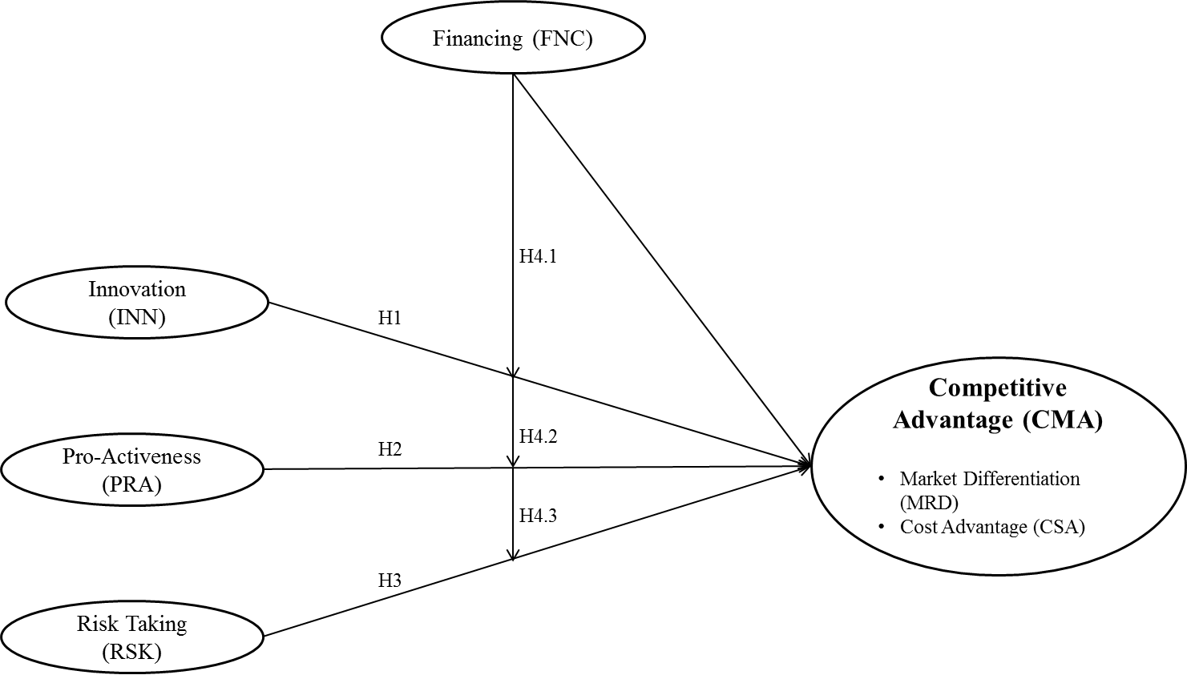
Figure 1, Proposed Theoretical Model

Entrepreneurial Orientation and Competitive Advantage
Studying strategy content (the generic strategies) with strategy making processes EO seems to be a logical choice of enquiry. EO is the starting point for creating and implementing competitive strategies. Hence, studying EO and competitive strategy is a promising research endeavor (Lechner & Gudmundsson, 2014; Rauch et al., 2009; Wales et al., 2011a). Van Geenhuizen et al. (2008) note that EO has emerged as a possible antidote to the problems facing businesses that wish to achieve a sustained competitive advantage. Thus, there is a particular interest in enriching the understanding of EO in an SME context. Different dimensions of EO (innovation, pro-activeness, and risk-taking) have differential impacts on the CA (Lechner & Gudmundsson, 2014).

Through the process of innovations firms discover ways to operate more efficiently. Market innovations contribute to a company's interest in operating more effectively; in that they help the firm identify new market space in which it can compete (Kuratko, Ireland, & Hornsby, 2001). Differentiation requires innovation capabilities, leading to new products that increase the value to the customer, justifying price premiums (Lechner & Gudmundsson, 2014). In the same context, Gitau et al., (2016) stress that the firm should continuously keen on introducing new and rapid innovations to their customers in order to keep its competiveness. Thus, greater innovativeness will lead to increasing the CMA in small firms. This leads to the first hypothesis:

H₁: Innovativeness positively influences CA in small firms.

Pro-activeness refers to how firms relate to market opportunities by seizing initiative in the marketplace (Y.-H. Li, Huang, & Tsai, 2009). At this point in tracing the link between EO and resource acquisition, it could be asserted that proactive firms seek specific and valuable resources to enhance their competitive advantage (Huang & Wang, 2011). Firms with higher EO will proactively work to obtain resources provided by the environment. These resources can then be employed in proactive and innovative projects enabling the firm to explore and exploit fertile opportunities associated with a munificent environment. Firms may also create innovative-resource combinations that makes them able to further invest such opportunities. Consequently, they are more likely to create competitive advantages and achieve higher performance levels (Rosenbusch, Rauch, & Bausch, 2013).

Small firms to be active in identifying and exploiting business opportunities, they need to be pro-active (Gitau et al., 2016). The pro-activeness dimension makes a firm to adopt continuous environmental scanning and acts in advance towards change to better serve customers and markets. Pro-activeness leverages the firm's responsiveness capability and propensity to act to meet new circumstances (Hughes & Morgan, 2007). Thus, a proactive firm tends to become first movers, and it is rewarded by marketplace positions of competitive advantage such as unusual returns, distribution channels, and brand recognition ( Li et al., 2009). Accordingly, it is hypothesized that:

H_{2:} Pro-activeness positively influences competitive advantage in small firms.

Risk-taking means a tendency to take bold actions such as venturing into unknown new markets, committing a large portion of resources to ventures with uncertain outcomes, and/ or borrowing heavily (Y.-H. Li et al., 2009; Walter, Auer, & Ritter, 2006). It involves the willingness to commit significant resources to opportunities, which have a chance to fail (Frese, Brantjes, & Hoorn, 2002). Risk-taking largely reflects the organization’s willingness to break away from the tried-and-true and venture into the unknown (Wiklund & Shepherd, 2003). It also allows the owners to make lucrative deals and it should, therefore, be positively related to success (Frese et al., 2002).
Differentiation strategies involve expending resources through research and development, marketing new products and services and promoting brand image (Porter, 1985). In addition, firm with making large resource commitments, obtain high returns by seizing opportunities in the marketplace (Lumpkin & Dess, 1996). Therefore, risk-taking should be more important for competitive advantage in small firms. This leads to the following hypothesis.
H₃: Risk-taking positively influences competitive advantage in small firms.

The Moderated role of Financing Support between Entrepreneurial Orientation and Competitive Advantage
SMEs competiveness in international markets relies on their access to vital resources that include finance, technology and managerial skills. The policy environment within which SMEs also operate plays a critical role in their competitiveness. If the policy environment is onerous and creates a burden on the operations of SMEs, it is likely to compromise their competitiveness (Sentsho, Maiketso, Sengwakets, Anderson, & Kayawe, 2007). In the same perception, Okpara ( 2011), stressed that since lack of finance support and corruption regarded as the most common constraints hindering SMEs growth and survival, it is the role of government to provide finance support to SMEs through government or through financing organization. Agyapong (2010), sees that it’s the government and policymakers role to provide viable credit support and non-financial business support services to help SMEs grow. Thus, according to previous studies, government financing support is to increase the SMEs competitiveness in both developed and developing countries (Agyapong, 2010; Ahmed, 2012; Aykan et al., 2013; Djankov, 2009; ECA, 2001; Gongera, Okoth, & Njuki, 2013; Okpara, 2011; Southiseng & Walsh, 2010).

The intervention of government increased the effect of the relationship between the values of entrepreneurs, firm financing, management and performance growth of SMEs (Shariff & Peou, 2008). In the same context, Abdullah & Hussin (2010) investigated the moderating effect of government assistance towards the improvement of business performance of turnaround companies. The study found that partial support in the moderating effect of government assistance and firm size and their influence in the relationship between strategy and successful turnaround. Therefore, the current study propose that FNC plays a positive role in the relationship between EO’s dimensions and CMA. Thus, the following hypothesis is formulated:

H_{4:} Financing support has a moderating role between the EO’s dimensions (innovativeness, pro-activeness, and risk-taking,) and competitive advantage in SMEs in Iraq.

Methodology
A quantitative approach was adopted in this study in which a cross-sectional survey was used. This design of the research was oriented towards observing the natural setting of the phenomenon under investigation and testing a number of hypotheses. The unit of analysis selected for this study was the organizational level particularly the owners or top management of SMEs. Random sampling was employed due to explanatory nature of this study.

Measurement and Instrumentation
The researchers developed an English-language questionnaire translated it into Kurdish language by a team of three researchers of different majors. All the items in the questionnaire were measured on a five point Likert scale ranging from ‘strongly disagree ’to ‘strongly agree’. All of these items were adapted from the existing literature. The current study includes three main variables, namely: entrepreneurial orientation (EO) as the independent variable, competitive advantage (CMA) as the dependent variable, and government Financial support (FNC) as a moderating variable. In this study, variable measurements have been selected from the existing scales in the literature. In addition, some of the items presented in this study are taken from the original source and changes are done according to the purpose of this study.

The items that used to measure EO’s dimensions (innovativeness, pro-activeness and risk-taking) were adapted from Miller (1983), the measurement of these items in turn, were used by (Covin and Slevin, 1989; Alarape, 2013; Lumpkin, Cogliser, and Schneider, 2009; and Yusof, 2009). There are 5 items that measure innovativeness, 6 items that measure pro-activeness and other 6 items for measuring risk-taking.
For measuring the dependent variable, this study operationalized competitive advantage as the result of a process of strategy formulation adopted by a firm with the purpose of providing added value through market differentiation and cost advantage to customers resulting in an advantageous position to the firm over their competitors for a period of time. The competitive advantage construct includes the dimensions of lower cost and market differentiation (Lechner & Gudmundsson, 2014; Ong et al., 2010). This study has used (16) items to measure the dependent variable. These items have been divided across market differentiation and cost advantages. Market differentiation had been measured by (8) items and cost advantage also measured by (8) items. The items have been adapted from Aljubouri (2005) because that study had been conducted in Iraqi environment. The current study also adapted three items from Li and Zhou (2010) to market differentiation and three other items for measuring cost advantage.

Regarding financial support (FNC) is operationalized as the condition in which government has the ability to assist SMEs in order to enable them be more competitive locally and globally through providing proper financing support ( Abdullah, 1999; Al-Hyari, 2013; Gisip & Harun, 2013; Shariff, Peou, & Ali, 2010). Items has been adapted from Moktan (2007) and (2) items have been added by the researcher.

Statistical analysis technique
this study used the structural equation modeling (SEM) method For analyzing both the measurement and structural models, as allows the incorporation of both unobserved (i.e. latent) and observed variables in the same model, , and it handles errors of measurement within exogenous variables having multiple indicators by the usage of confirmatory factor analysis. Additionally, SEM permits simultaneous analysis of multiple linear regression between the independent variables, multiple path analysis, assess the direct and indirect effect, and fitness of overall model which is not feasible in a traditional regression analysis method(Chin, Marcolin, & Newsted, 2003; Gefen, Straub, & Boudreau, 2000). Another advantage of SEM method is that it conceptualizes a variety of relations between a ranges of variables. SEM can also provide measures of fit to assess the entire model (Smith & Langfield-smith, 2004). Smart PLS applies many methodological approaches to calculate SEM. The advantage of using PLS path modeling is that it can estimate very complex models with many latent and observed variables. Also PLS technique is suitable for prediction-oriented research. The powerful feature of PLS path modeling is that it assesses very complex models having many latent and manifest variables. Also PLS technique is useful for prediction-oriented research. Thereby, the methodology assists researchers who focus on the explanation of endogenous constructs.

Data analysis

Sample Demographic Profile
Over 580 collected questionnaires, 562 useful responses were received from the male (96.9%) and only 18 from the female (3.1%). Therefore, the sample of this study is mainly dominated by male. Regarding the respondents age, 18.4% of the respondents stated that they had less than 30 years old, 30 to 35 were 25.9%, 36 to 41 years old years old, were 29.7% , 17.1% had 42 to 47 years old and only 9.0% had more than 47 years old. In specifying the marital status of the respondents, 82.4% of them were single and only 17.6% were married. About 18.3% of the respondents stated that they have less than 5 years of experiences. 40.0% have 5 to 10, 20.2% have 11 to 15 and 21.6% of the respondents have more than 15 years of working experience. Regarding the study level of respondents, 51.9% of the responders were Secondary, 22.6% were Diploma, 18.6% were Bachelors and 6.9% were others. In specifying the Years of Establishment in Business, 26% of the respondents stated less than 5 year, 50% stated 5 to 10 year, 14% stated 11 to 15 years and 10% stated more than 15 year. Finally the respondents were asked to specify the number of workers. As the results, 62.9% of them have less than 11 workers while 37.1% have 11 to 99 workers.

Measure Reliability and Validity
Confirmatory factor analysis (CFA) was applied to assess the reliability and validity of the measures that adapted from the previous studies. The results are showed in Table 1.
Table 1: Result of CFA for Measurement Model
Construct | Item | Convergent Validity |  |  | Internal  Reliability  Cronbach Alpha
 |  | Factor  Loading | Average Variance Extracted (AVE)ª | Composite Reliability (CR)^{b}
Innovation (INN) | INN1 | 0.809 | 0.636 | 0.897 | 0.857
 | INN2 | 0.781
 | INN3 | 0.743
 | INN4 | 0.821
 | INN5 | 0.830
Pro-Activeness (PRA) | PRA1 | 0.813 | 0.626 | 0.893 | 0.850
 | PRA2 | 0.802
 | PRA3 | 0.789
 | PRA4 | 0.794
 | PRA5 | 0.391 ^{c}
 | PRA6 | 0.756
Risk Taking (RSK) | RSK1 | 0.717 | 0.563 | 0.865 | 0.805
 | RSK2 | 0.763
 | RSK3 | 0.780
 | RSK4 | 0.768
 | RSK5 | 0.720
 | RSK6 | 0.285 ^{c}
Financing (FNC) | FNC1 | 0.883 | 0.767 | 0.952 | 0.939
 | FNC2 | 0.906
 | FNC3 | 0.892
 | FNC4 | 0.870
 | FNC5 | 0.892
 | FNC6 | 0.806
 | FNC7 | 0.126^{c}
 | FNC8 | 0.090 ^{c}
Market Differentiation (MRD) | MRD1 | 0.525 ^{c} | 0.627 | 0.922 | 0.901
 | MRD2 | 0.781
 | MRD3 | 0.815
 | MRD4 | 0.749
 | MRD5 | 0.818
 | MRD6 | 0.818
 | MRD7 | 0.778
 | MRD8 | 0.781
Cost Advantage (CSA) | CSA1 | 0.747 | 0.582 | 0.907 | 0.879
 | CSA2 | 0.776
 | CSA3 | 0.839
 | CSA4 | 0.390^{c}
 | CSA5 | 0.768
 | CSA6 | 0.689
 | CSA7 | 0.716
 | CSA8 | 0.796
Competitive Advantage (CMA) | Market Differentiation (MRD) | 0.912 | 0.831 | 0.908 | 0.797
 | Cost Advantage (CSA) | 0.911
Notes: ª: AVE= Σ λi 2/ n λ = Standardized Factor Loading n = Number of Item in a Model
^{b}: CR = (Σᶄ ) 2 / [(Σᶄ ) 2 + (Σ l- ᶄ2)] ᶄ2 = Factor loading of every item
^{c} denotes for discarded item due to insufficient factor loading that was below cut-off 0.6

In this study, the convergent validity of the measures was tested. Convergent validity is the degree to which multiple attempts to measure the same concept in agreement. The factor loadings, composite reliability and average variance extracted were used to assess convergence validity as suggested by Hair, Black, Babin, & Anderson, (2010). After discarding 7 items (i.e., PRA5, RSK6, RGL2, RGL3, RGL7, MRD1 and CSA4) due to insufficient factor loading below 0.6, the factor loadings of all remaining items range from 0.689 to 0.912, exceeded the threshold of 0.6 as recommended by Hair et al, 2006.
The average variance extracted, which reflect the overall amount of variance in the indicators accounted for by the latent construct, were in the range of 0.563 and 0.831 which were all above the recommended value of 0.5 (Hair et al., 2010). Composite reliability values, which depict the degree to which the construct indicators indicate the latent construct, range from 0.865 to 0.952which exceeded the recommended value of 0.6 (Hair et al., 2010). In the next step, the inter-item consistency reliability value of Cronbach alpha was used to measure the reliability of the measures. The values range from 0.797 to 0.939 which were above the threshold of 0.7 as suggested by Nunnally and Bernstein (1994).
In this study two approaches were used to test the discriminant validity of the constructs. First the correlations between the constructs were examined, which revealed that the correlations between the constructs were all below the threshold 0.85 (Kline, 2011). Second, the criterion of Fornell & Larcker, (1981) was applied to test whether each construct’s square rooted AVE is greater than its correlations with the remaining constructs. As shown in Table 2, both analyses confirm the discriminant validity of all constructs. In total, the measurement model demonstrated adequate reliability, convergent validity and discriminant validity.
Table 2: Discriminant Validity of Constructs
 | INN | PRA | RSK | FNC | CMA
Innovation (INN) | 0.797
Pro-Activeness (PRA) | 0.549 | 0.791
Risk Taking (RSK) | 0.392 | 0.457 | 0.750
Financing (FNC) | 0.074 | 0.047 | 0.105 | 0.876
Competitive Advantage (CMA) | 0.480 | 0.496 | 0.472 | 0.174 | 0.912
Notes. Diagonals represent the average variance extracted, while the other matrix entries represent the square correlations.

Structural Model
With the satisfactory results in the measurement model, the structural model was evaluated subsequently. The predictive accuracy of the model was evaluated in terms of the portion of variance explained (R²). The results suggest that the model is capable of explaining 44.3 % of the variance in competitive advantages. Besides estimating the magnitude of R², researchers have recently included predictive relevance developed by Geisser, (1975) and (Stone, 1974), as additional model fit assessment. This technique show the model adequacy to predict the manifest indicators of each latent construct. Stone-Geisser Q² (cross-validated redundancy) was computed to examine the predictive relevance using a blindfolding procedure in PLS. Following the guidelines suggested by Chin, (2010), the values of Q² for competitive advantages was 0.355, far greater than zero which refers to predictive relevance of the model. In sum, the model exhibits acceptable fit and high predictive relevance.

Nonparametric bootstrapping was applied with 1000 replications to test structural model (Wetzels, Odekerken-Schröder, & van Oppen, 2009). The structural model resulting from the PLS analysis is summarized in Figure 2.

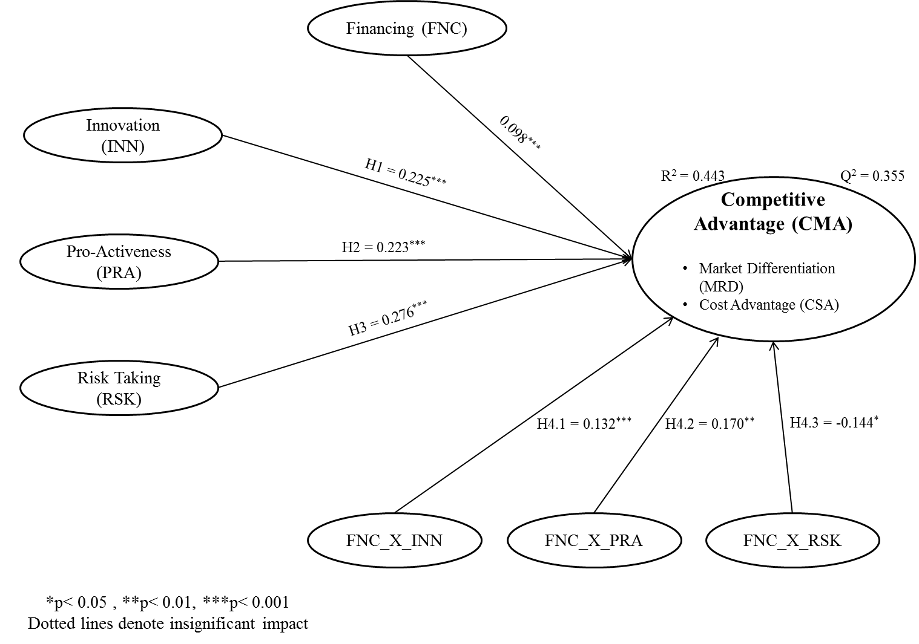
Figure 2: PLS Analysis of the Structural Model

As shown in Figure 2, all of the hypotheses were supported. The details of examining hypotheses are presented in Table 3.
Table 3, Examining Results of Hypotheses
Path Shape | Path Coefficient | Standard Error | T-value | P-value | Hypothesis Result
INN CMA | 0.238*** | 0.036 | 6.660 | 0.000 | H1) Supported
PRA CMA | 0.242*** | 0.046 | 5.320 | 0.000 | H2) Supported
RSK CMA | 0.256*** | 0.041 | 6.301 | 0.000 | H3) Supported
(FNC * INN) CMA | 0.132*** | 0.034 | 3.912 | 0.000 | H4.1) Supported
(FNC * PRA) CMA | 0.170** | 0.052 | 3.305 | 0.001 | H4.2) Supported
(FNC * RSK) CMA | -0.144* | 0.071 | 2.025 | 0.043 | H4.3) Supported
*p< 0.05, **p< 0.01, and ***p< 0.001

As highlighted in Table 3, the direct effects of Innovation (INN), Pro-Activeness (PRA) and Risk Taking (RSK) on Competitive Advantage (CMA) were 0.238, 0.242 and 0.256 respectively. All of these effects were positive and significant as their p-values were all significance at 0.001 level. Therefore, the hypotheses H1, H2 and H3 were supported the model. The results of moderation analysis indicated that the interaction terms of Financing (FNC) with Innovation (INN), Pro-Activeness (PRA) and Risk Taking (RSK) had significant effects on Competitive Advantage (CMA) as all p-values were lower than the standard significance level of 0.05. The relative path coefficients were 0.132, 0.170 and -0.144 respectively. These results demonstrated that Financing (FNC) moderates the effects of Innovation (INN), Pro-Activeness (PRA) and Risk Taking (RSK) on Competitive Advantage (CMA). Therefore hypotheses H4.1, H4.2 and H4.3 were supported. Figure 3 shows the graphs of moderating effects of Financing (FNC) on the relationships between Innovation (INN), Pro-Activeness (PRA) and Risk Taking (RSK) as predictors and Competitive Advantage (CMA) as criterion.

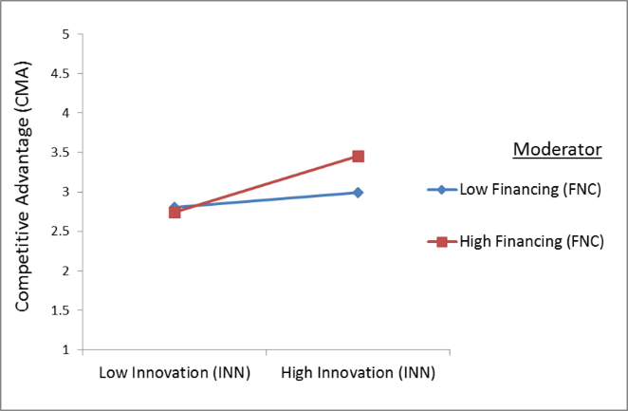
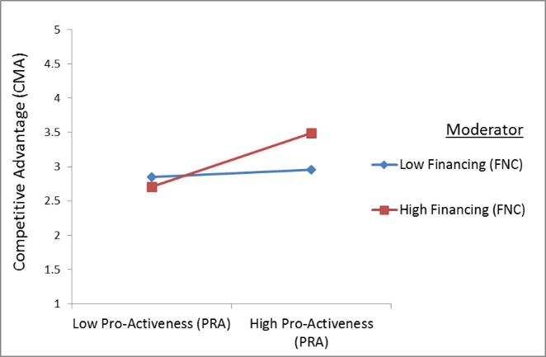
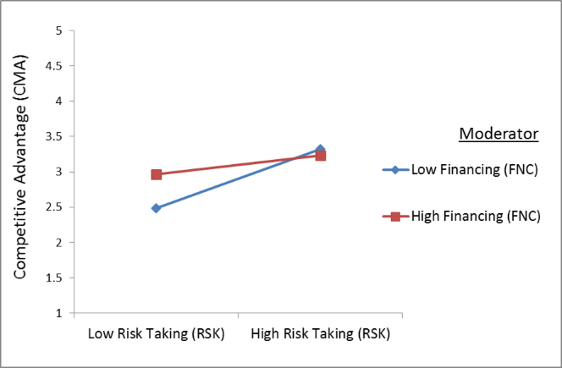

Figure 3: Moderation Effects of Financing on the Relationships between Innovation, Pro-Activeness and Risk Taking and Competitive Advantage

As shown in Figure 3, the two lines in each moderation graph indicated a positive relationship between the predictors and criterion. Due to The two lines were not parallel this mean that the moderating effects of Financing is existing. The relationships between Innovation and Pro-Activeness as predictors and Competitive Advantage as criterion were greater for the high level of financing compare to the low level. Hence, it could be concluded that the Financing strengthen the positive effects of Innovation and Pro-Activeness on the Competitive Advantage. Conversely, the direct relationship between Risk Taking and Competitive Advantage become greater were the low level of financing existing compare to the high level of financing support. Hence, it could be concluded that the Financing weaken the positive effects of Risk Taking on the Competitive Advantage.

Discussion
The first objective of this study was to investigate the influence of each individual dimension of EO (INN , PRA, and RSK) on CMA. The influence of EOs dimension on CMA is represented by hypothesis H1, H2. and H3. The statistical results reveal a direct significant and positive relationship between each individual EOs dimension and CMA. As shown in Table 3, the direct effects of INN, PRA and RSK on CMA were 0.238, 0.242 and 0.256 respectively. All of these effects were positive and statistically significant as their p-values were all significance at 0.001 level. Thus, the hypotheses H1, H2 and H3 were supported. This finding is generally consistent with previous studies Gitau et al., (2016); Kuratko et al., (2001); Lechner & Gudmundsson, (2014) that illustrated that each of EO's dimension had significant influence on CMA.

The second objective of this study was to examine the moderated role of FNC between each individual EOs dimension and CMA. The moderated role between the influences of each EOs dimension on CMA is represented by hypothesis H4.1, H4.2. and H4.3. The statistical results show that FS moderated the influence of each individual EOs dimension on CMA. The results of moderation analysis indicated that the interaction terms of FNC with INN, PRA and RSK had significant effects on CMA as all p-values were lower than the standard significance level of 0.05. The relative path coefficients were 0.132, 0.170 and -0.144 respectively. These results demonstrated that FNC moderates the effects of INN, PRA and Taking RSK on CMA. Therefore hypotheses H4.1, H4.2 and H4.3 were supported.

The results of this study, support theorizing that FNC serves as an important factor for the influence of EO practices on CMA. Indeed, the relationship between EO practices and CMA is stronger for firms that are supported from the government. These findings provide preliminary support for (Messersmith & Wales, (2011); Moreno & Casillas, (2008); Wales, Gupta, & Mousa, (2011) who assertion that the influence of EO practices firm performance may depend on a moderator or mediator environmental variables.

Conclusions and policy implications
This study attempted to examine the EO's dimension, CMA, and FNC in Kurdistan Region SMEs. More specifically, the objective was to explain the influence of EO’s dimension on CMA, as well as the moderating effect of FS on the relationship between each dimension of EO and CMA. Structural Equation Modelling (SEM) was employed to examine the relationship among the variables. The targeted sample size was 680 from a total manager population in 3526 SMEs working in Kurdistan Region Government (KRG) in Iraq. Based on 580 usable questionnaires, the results of this study indicate that each individual dimension of EO (INN, PRA, and RSK) had positive and significant influence on CMA. The results also reveal that FNC moderated the relationship between each dimension of EO and CMA.
This study has several implications for policymakers, researchers and small firm owner/managers. It contribute to existing literature through addressing the issues that, in previous study, had been suggested to advance EO understanding: to analyze the effect of each individual EO dimensions on CMA. Competitive advantage matters for small firms because individual EO dimensions would impact upon the two competitive advantage. The study has confirmed that the EO dimensions do an effect on CMA positively, and advances the understanding of the relative impact of EO dimensions on CMA. The study also contributes to integrate the field of EO with CMA through moderator variable that FNC that consisted with the suggestion of previous studies variables Messersmith and Wales, (2011); Moreno and Casillas, (2008); Rauch et al., (2009); Wales et al., (2011a) that argued that the relationship between EO and CMA is moderated or mediated by external variables. Thus the finding of this study may lead and promote researcher for understanding of the cross-contextual variation of the EO–CMA link
The implication of this study to small firm owner/managers is that, it shows entrepreneurship as an essential tool for exploring and exploiting opportunities. In addition, successful small firms have an important contributors to regional and national economy. If the policy makers aim to create more employment opportunities and economic development through successful small firms, they have to develop systems that emphasize the importance of ‘‘entrepreneurship’’ for the small firm.
This study has some limitations. First, it focused on SMEs in Iraq, which make difficult to generalize its result, due to the context of the study was focus in the local scale. The researchers propose to do similar studies on SMEs in other countries. Second, this study examined the moderated role of FNC between EO and CMA. However, this study do not focus on other types of governmental support that may affect the relationship between EO and CMA. Thus, further study might gain additional insight by exploring other moderator such as regulations, programs support, training, and infrastructure.

References

Abdullah, M. A. (1999). The accessibility of the government-sponsored support programmes for small and medium-sized enterprises in Penang. Cities, 16(2), 83–92.

Abdullah, T. M. C., & Hussin, Z. (2010). Moderating effect of government assistance and turnaround strategies "a research on private manufacturing companies. Journal of Global Strategic Management, 4(1), 64–73.
Ackah, A. J. (2011). The challenges faced by small & medium enterprises ( SMEs ) in obtaining credit in Ghana . Blekinge Tekniska Hogskola.
Agyapong, D. (2010). Micro , small and medium enterprises ’ activities , income level and poverty reduction in Ghana –a synthesis of related literature. International Journal of Business and Management, 5(12), 196–205.
Ahmed, S. Z. (2012). Micro, small and medium-sized enterprises development in the Kingdom of Saudi Arabia Problems and constraints. World Journal of Entrepreneurship, Management and Sustainable Development, 8(4), 217–232.
Akyüz, K. C., Akyüz, İ., Serіn, H., & Cindik, H. (2006). The financing preferences and capital structure of micro, small and medium sized firm owners in forest products industry in Turkey. Forest Policy and Economics, 8(3), 301–311.
Alarape, A. A. (2013). Entrepreneurial orientation and the growth performance of small and medium enterprises in Southwestern Nigeria. Journal of Small Business & Entrepreneurship, 26, 553–577.
Al-Hyari, K. (2013). Identification of barrier factors and potential solutions to SMEs development among Jordanian manufacturing sector. International Journal of Business and Management, 8(24), 132–141.
Aljubouri, A. H. . O. (2005). The impact of competitive strategies in consolidation strategic performance. University of Mousl.
Alvarez, S. A., & Busenitz, L. W. (2001). The entrepreneurship of resource-based theory. Journal of Management.
Aykan, E., Aksoylu, S., & Sönmez, E. (2013). Effects of Support Programs on Corporate Strategies of Small and Medium-sized Enterprises. Procedia - Social and Behavioral Sciences, 99, 938–946.
Bateman, thomas S., & Snell, S. A. (2004). Management : the new competitive landscope (6th ed). New York: McGraw Hill.
Beyene, A. (2002). Enhancing the Competitiveness and Productivity of Small and Medium Scale Enterprises ( SMEs ) in Africa : An Analysis of Differential Roles of National Governments Through Improved Support Services. Journal of Global Strategic Management, 27(3), 130–156.
Burke, R. J., & El-Kot, G. (2014). Human Resource Management Practices in Small- and Medium-Sized Enterprises in Egypt. Journal of Transnational Management, 19(3), 211–226.
Chidoko, C., Makuyana, G., Matungamire, P., & Bemani, J. (2011). IMPACT OF THE INFORMAL SECTOR ON THE CURRENT Zimbabwean economic environment. International Journal of Economics and Research, 2(6), 26–28.
Chin, W. W. (2010). Handbook of Partial Least Squares. Springer.
Chin, W. W., Marcolin, B. L., & Newsted, P. R. (2003). A Partial Least Squares Latent Variable Modeling Approach for Measuring Interaction Effects : Results from A Partial Least Squares Latent Variable Modeling Approach for Measuring Interaction Effects : Results from a Monte Carlo Simulation Study and an Ele, (May 2014).
Covin, J. G., & Slevin, D. (1991). A conceptual model of entrepreneurship as firm behavior. Entrepreneurship Theory and Practice, 16(1), 7–25.
Covin, J. G., & Slevin, D. P. (1989). Strategic Management of Small Firms in Hostile and Benign Environments. Strategic Management Journal, 10(March 1987), 75–87.
Covin, J., & Slevin, D. (1988). The influence of organization structure on the utility of an entrepreneurial top management style. Journal of Management Studies, 25(May), 217–234.
Djankov, S. (2009). The regulation of entry: A survey. The World Bank Research Observer, 24(2), 183–203.
ECA. (2001). Enhancing the Competitiveness of Small and Medium Enterprises in Africa : A Strategic Framework for Support Services.
Fornell, C., & Larcker, D. F. (1981). Evaluating Structural Equation Models with Unobservable Variables and Measurement Error. Journal of Marketing Research, 18(1), 39–50.
Frese, M., Brantjes, a., & Hoorn, R. (2002). Psychological Success Factors of Small Scale Businesses in Namibia: The Roles of Strategy Process, Entrepreneurial Orientation and the Environment. Journal Of Developmental Entrepreneurship.
Gefen, D., Straub, D. W., & Boudreau, M.-C. (2000). Structural Equation Modeling and Regression : Guidelines for Research Practice. Communications of the Association for Information Systems, 4(7). http://doi.org/10.1.1.25.781
Geisser, S. (1975). The predictive sample reuse method with applications. Journal of the American Statistical Association, 70(350), 320–328.
Gisip, I., & Harun, H. (2013). An Assessment of Government Support Programs in the Development of SMEs in Malaysia: Issues and Challenges. Scottish Journal of Arts, Social Sciences and Scientific Studies, 8(2), 9–18.
Gitau, G., Mukulu, E., & Kihoro, J. (2016). Influence of Entrepreneurial Orientation on Competitive Advantage among Mobile Service Providers in Kenya, 3(2), 2010–2016.
Gongera, E., Okoth, O. N., & Njuki, H. M. (2013). The Role of the Government in the Performance of Small Scale Enterprises in Dar es Salaam. European Journal of Business and Management, 5(17), 120–126.
Gürbüz, G., & Aykol, S. (2009). Entrepreneurial management, entrepreneurial orientation and Turkish small firm growth. Management Research News, 32(4), 321–336.
Hair, J. F., Black, W. C., Babin, B. J., & Anderson, R. E. (2010). multivariate Data analysis (7th ed). New York: Prentice prentice Hall.
Haron, D. H., Ismail, D. I., Khalid, S. N. A., & Ganesan, Y. (2010). Cases of successful Malaysian small and medium enterprises (SMEs): Does business advisory services help? Malaysia Accountancy Research and Education (MAREF).
Hughes, M., & Morgan, R. E. (2007). Deconstructing the relationship between entrepreneurial orientation and business performance at the embryonic stage of firm growth. Industrial Marketing Management, 36(5), 651–661.
Kline, R. B. (2011). Principles and practice of structural equation modeling. Structural Equation Modeling (erd ed, Vol. 156). New York: Guilford Press.
Knight, G. A. (1997). Cross-cultural Reliability and Validity of a Scale to Measure Firm Entrepreneurial Orientation. Journal of Business Venturing, 12(3), 213–225.
Kreiser, P. M., Marino, L. D., & Weaver, K. M. (2002). Assessing the Psychometric Properties of the Entrepreneurial Orientation Scale: A Multi-Country Analysis. Entrepreneurship: Theory & Practice, 26(4), 71.
Kuratko, D. F., Ireland, R. D., & Hornsby, J. S. (2001). Improving firm performance through entrepreneurial actions: Acordia’s corporate entrepreneurship strategy. Academy of Management Executive, 15(4), 60–71.
Lechner, C., & Gudmundsson, S. V. (2014). Entrepreneurial orientation, firm strategy and small firm performance. International Small Business Journal, 32(1), 36–60.
Li, J. J., & Zhou, K. Z. (2010). How foreign firms achieve competitive advantage in the Chinese emerging economy: Managerial ties and market orientation. Journal of Business Research, 63(8), 856–862.
Li, Y.-H., Huang, J.-W., & Tsai, M.-T. (2009). Entrepreneurial orientation and firm performance: The role of knowledge creation process. Industrial Marketing Management, 38(4), 440–449.
Lumpkin, G. T., Cogliser, C. C., & Schneider, D. R. (2009). Understanding and Measuring Autonomy: An Entrepreneurial Orientation Perspective. Seizure, 14(806), 47–70.
Lumpkin, G. T., & Dess, G. G. (1996). Clarifying the entrepreneurial orientation construct and linking it to performance. Academy of Management Review, 21, 135–172.
Lyon, D. W., Lumpkin, G. T., & Dess, G. D. (2000). Enhancing entrepreneurial orientation research: Operationalizing and measuring a key strategic decision making process. Journal of Management, 26(5), 1055–1085.
Manimala, M. J., & Kumar, S. (2012). Training Needs of Small and Medium Enterprises: Findings from an Empirical Investigation. IIM Kozhikode Society & Management Review, 1(2), 97–110.
Meng, M. S. I. Bs. (2005). A critical study on the strategy for capital machinery manufacturing SMEs in Bangladesh. Dublin City University, Ireland.
Messersmith, J. G., & Wales, W. J. (2011). Entrepreneurial orientation and performance in young firms: The role of human resource management. International Small Business Journal, 31(2), 115–136.
Miller, D. (1983). The Correlates of Entrepreneurship in Three Types of Firms. Management Science, 29(7), 770–791.
Moreno, A. M., & Casillas, J. C. (2008). Entrepreneurial orientation and growth of SMEs: A causal model. Entrepreneurship: Theory and Practice, 32(3), 507–528.
Mosakowski, E. (1998). Entrepreneurial Resources, Organizational Choices, and Competitive Outcomes. Organization Science.
Nasution, H. N., Mavondo, F. T., Matanda, M. J., & Ndubisi, N. O. (2011). Entrepreneurship: Its relationship with market orientation and learning orientation and as antecedents to innovation and customer value. Industrial Marketing Management, 40(3), 336–345.
Nunnally, J.C. and Bernstein, I. . (1994). Psychometric Theory. New York: McGraw-Hill.
OECD. (1998). Small Businesses, Job creation and Growth: Facts, Obstacles and Best Practices. Paris: France.
Okpara, J. O. (2011). Factors constraining the growth and survival of SMEs in Nigeria: Implications for poverty alleviation. Management Research Review, 34(2), 156–171.
Ong, J. W., Ismail, H. Bin, & Goh, G. G. G. (2010). The Competitive Advantage of Small and Medium Enterprises (SMEs): The Role of Entrepreneurship and Luck. Journal of Small Business & Entrepreneurship, 23(November 2014), 373–391.
Rosenbusch, N., Rauch, A., & Bausch, A. (2013). The Mediating Role of Entrepreneurial Orientation in the Task Environment-Performance Relationship: A Meta-Analysis. Journal of Management, 39(3), 633–659.
Rothaermel, F. T. (2013). Strategic Management , Concepts and Cases. New York: McGraw Hill/ Irwan.
Schlögl, H. (2004). Small and medium enterprises: Seizing the potential. Organizational for Economic Cooperation and Development, 243(May), 46–48.
Sentsho, J., Maiketso, J. T., Sengwakets, M., Anderson, V. N., & Kayawe, T. (2007). Performance and competitiveness of small and medium sized manufacturing enterprises in Botswana. Gaborone, Botswana: BIDPA.
Shariff, M. N. M., Peou, C., & Ali, J. (2010). Moderating effect of government policy on entrepreneurship and growth performance of small-medium enterprises in Cambodia. International Journal of Business and Management Science, 3(1), 57–72.
Shariff, M., & Peou, C. (2008). The relationship of entrepreneurial values, firm financing and the management and growth performance of small-medium enterprises in Cambodia. Problems and Perspectives in Management, 6(4), 55–64.
Smith, D., & Langfield-smith, K. (2004). Structural Equation Modeling in Management Accounting Resear.
Southiseng, N., & Walsh, J. (2010). Competition and Management Issues of SME Entrepreneurs in Laos : Evidence from Empirical Studies in Vientiane Municipality , Savannakhet and Luang Prabang. Asian Journal of Business Management, 2(3), 57–72.
Stel, A. van, Storey, D., & Thurik, R. (2006). The effect of business regulations on nascent and actual entrepreneurship. Papers on Entrepreneurship, Growth and Public Policy., (No. 0406), 31.
Stone, M. (1974). Cross-Validatory Choice and Assessment of Statistical Predictions. Journal of the Royal Statistical Society, 36(2), 111–147.
Thompson, J. L. (2001). strategy management (5th ed). London: Thomsom Learning.
Wales, W. J., Gupta, V. K., & Mousa, F.-T. (2011). Empirical research on entrepreneurial orientation: An assessment and suggestions for future research. International Small Business Journal, 3(4), 357–383.
Walter, A., Auer, M., & Ritter, T. (2006). The impact of network capabilities and entrepreneurial orientation on university spin-off performance. Journal of Business Venturing, 21(4), 541–567.
Wetzels, M., Odekerken-Schröder, G., & van Oppen, C. (2009). Using PLS path modeling for assessing hierarchical construct models: guidelines and empirical illustration. MIS Quarterly, 33(1), 177–195.
Wiklund, J., & Shepherd, D. (2003). Knowledge-based resources, entrepreneurial orientation, and the performance of small and medium-sized businesses. Strategic Management Journal, 24(13), 1307–1314.
Wiklund, J., & Shepherd, D. (2005). Entrepreneurial orientation and small business performance: a configurational approach. Journal of Business Venturing, 20(1), 71–91.
Yusof, M. (2009). Entrepreneurial Leadership and Academic Entrepreneurship in Malaysian Public Research Universities. International Journal of Entrepreneurship and Innovation Management.
Zulkifli, R., & Rosli, M. (2013). Entrepreneurial Orientation and Business Success of Malay Entrepreneurs: Religiosity as Moderator. International Journal of Humanities and Social Science, 3(10), 264–275.

