ENERGY CONSERVATION AND ENERGY MANAGEMENT FOR INDUSTRY IN INDONESIA IN ISLAMIC ECONOMIC PERSPECTIVE

FIGURES

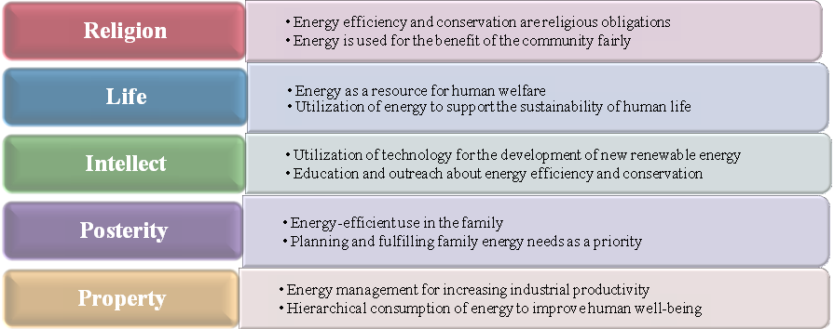

Figure 1: Maqashid al-Shariah Development Model for Sustainable Energy Conservation

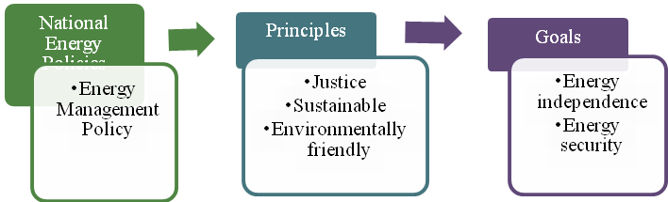

Figure 2: National Energy Policies (KEN) in Indonesia

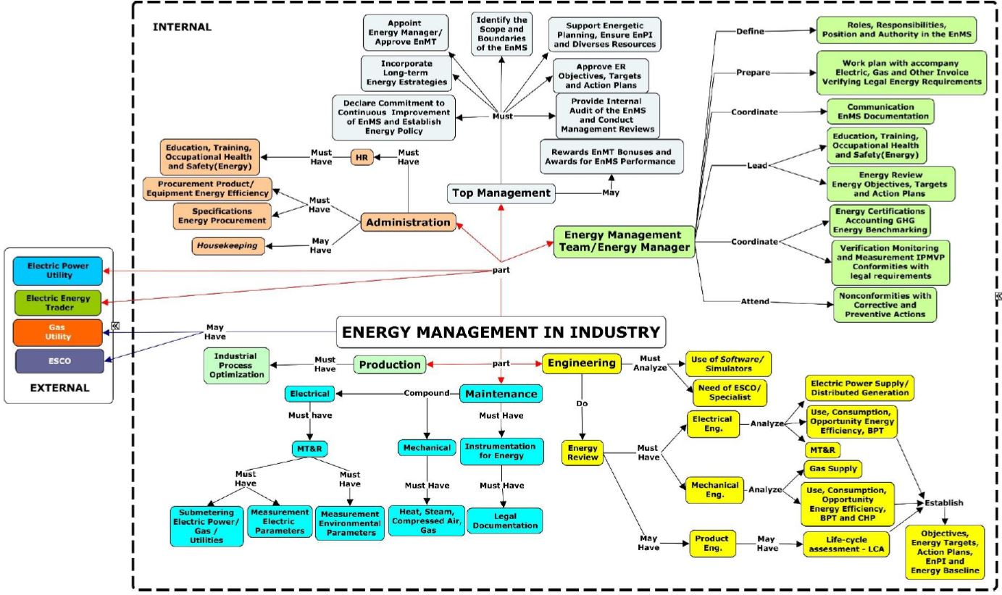

Figure 3: Conceptual Map for an Energy Management System in an Industrial Company

TABLES

Table 1: Five Basic Principles of Maqasid al-Shariah and the Five Pillars of Sustainable Development

No. | 5 Basic Principles of Maqasid al-Shariah | Objectives and Goals | 5 Pillars of SDGs | Objectives and Goals
1 | Religion | a. Humans have the responsibility of managing the universe properly as part of religious obligations  b. Humans do not make damage on earth, such as exploitation which is detrimental to humans and  the environment as a religious order.  c. Humans must act efficiently in the use of energy resources  d. To create a peaceful, just and inclusive society that is free from fear and violence. | People | a. To end poverty and hunger  b. Guaranteeing the fulfillment of human potential, dignity, equality in a healthy environment
2 | Life | a. Humans as potential creatures who have the main task to manage and prosper the earth  b. Man's obligation is to create goodness in realizing the lives of all beings on the planet. | Planet | a. Protect the planet from degradation through consumption and production and manage natural resources sustainably  b. Take quick action on climate change that supports the needs of present and future generations
3 | Intellect | a. Humans have the potential for reason in creating technology to manage the earth and natural resources  b. Humans think of the entire universe in glorifying the greatness of God and enjoy all His gifts to meet the needs of life and carry on with his life. | Prosperity | a. To create a prosperous and satisfying life for all humans  b. Aligning economic, social and technological progress with nature.
4 | Posterity | a. Realizing human survival with efficiency measures in meeting energy consumption needs and avoiding energy crises for future generations.  b. Develop new renewable energy and energy conservation for energy savings that have an impact on human life in the future. | Peace | Fostering a peaceful, just and inclusive society that is free from fear and violence
5 | Property | a. Carry out environmental and energy conservation as a religious obligation  b. Commit exploitation and damage to the environment, as well as mistakes in the management of natural resources as an evil deed | Partnership | Mobilize global partnerships to achieve sustainable development focused on the needs of the poorest and most vulnerable

Table 2: Moral Values ​​for Energy Conservation in the Qur'an

No | Moral Values | Surah and Verses of the Qur'an | Issues of Energy Conservation
1 | Justice | Al-Nisa’, 4: 135; | Energy management that is fair and equitable
 |  | Al-An’am, 6: 152 | Fair energy policy
2 | Benefit | Al-Baqarah, 2: 195 | Utilization of energy for the welfare of the community as worship; keep the environment from pollution, and make energy savings.
 |  | Al-Qashash, 22: 76-77 | Prohibition of doing damage on earth, such as exploitation of energy sources, environmental pollution, and energy waste.
3 | Self Sacrifice | Al-Hashr, 59: 9 | Promote energy saving, energy subsidies, energy conservation.
 |  | Hud, 11: 61 | The role of everyone in the welfare of the earth, the use of geothermal energy, the development of renewable energy sources.
4 | Generosity | Al-Mu’minun, 23: 18-22 | Encouragement of research and technology creation to find renewable energy sources (rainwater, plants and fruit, oil-producing timber trees, livestock, marine), and energy conservation.
5 | Gratefulness | Ibrahim, 14: 7 | Give thanks for Allah's blessings through environmental preservation and energy utilization, energy conservation, and energy efficiency.
 |  | Al-Isra’, 17: 29-30 | Prohibition of exploitation and waste of energy, conduct energy efficiency, and plan for sustainable energy.
6 | Consideration for Others | Al-Hadid, 57: 23-24 | Preventing energy crisis by making energy savings in daily life, and sustainable energy.
7 | Energy saving | Al-An’am, 6: 141 | Energy management, the use of plants and fruits as energy, supporting and fulfilling energy needs, and prohibiting energy waste.
Source: Hasanuz Zaman (1999)

Table 3: Plan, Do, Check, Action (PDCA) Cycles in Energy Management

PLAN | DO | CHECK | ACTION
Conduct energy reviews and establish baselines, energy performance indicators, objectives, targets and action plans needed to provide results that will improve energy performance in accordance with the organization's energy policy. | Implement energy management action plans | Monitor and measure the processes and key characteristics of operations that determine energy performance against energy policies and objectives and report results | Take action to continuously improve energy performance and the Energy Management System (EnMS)

Table 4: Drivers of energy conservation policies in Indonesia

No | Boosters | General Purposes
1 | Economic Growth and Competitiveness | a. Reducing energy intensity  b. Increase industrial competitiveness  c. Reducing production costs  d. Energy costs are more affordable
2 | Enerby resistance | a. Reducing energy imports
b. Maximizing for domestic needs and reducing exports
c. Increase reliability
d. Control the growth of energy demand
e. Encourage energy diversification by maximizing new and renewable energy (EBT)
3 | Climate Change | a. Global mitigation and adaptation efforts  b. Fulfill international obligations under the United Nations Framework Convention on Climate Change UNFCCC

